Assessing the impact of urban heating on tree growth in Berlin with open inventory and environmental data

Alexander G. Hurley $​^{a*}$, Ingo Heinrich $​^{a}$, …

$​^{a}$*Geoforschungszentrum Potsdam, Section 4.3, Germany*

* Corresponding author: [hurley@gfz-potsdam.de](mailto:hurley@gfz-potsdam.de)

30 November, 2021

**This document outlines the rationale for an analysis of tree growth (potential) and its relationship with the Urban Heat Island (UHI) effect in Berlin using an extensive, publicly available data set. It introduces preliminary results and provides an outlook for up-coming and potential work.**

# 1 Introduction

The manifold ecological and societal benefits urban trees provide (e.g., Roy et al., 2012) depend critically on their health and performance. For instance, trees alter local energy budgets (Grimmond et al., 1996 ; Hertel and Schlink, 2019) through shading and transpiration (Endlicher et al., 2016; Gillner et al., 2015), and therefore can reduce ambient temperatures, infrastructure power-consumption and (human) thermal discomfort (Akbari et al., 2001; e.g. Gulyás et al., 2006; Hoyano, 1988; Mayer and Höppe, 1987). However, excess heat common for cities (i.e., Urban Heat Island, UHI, Oke, 1982), combined with other urban conditions, affects tree physiological functioning with outcomes ranging from enhanced growth to early senescence, branch die-back, and even mortality (Au, 2018; Gillner et al., 2014; e.g., Hilbert et al., 2019). Thus, assessing the effect of increased temperatures on trees, as part of urban green infrastructure, is instrumental for understanding as well as adapting to current and expected conditions in this century (Ward and Johnson, 2007), especially considering ever more urbanized societies and the potential for UHI effects to compound with more frequent atmospheric drought (Brune, 2016; Norton et al., 2015; Roloff et al., 2009).

The UHI effect, i.e., the difference between urban and adjacent rural (air) temperatures, has been intensively studied for several decades (cf. Oke, 1982; Stewart, 2011). It is typically related to the structure and density of urban land-use (Kuttler et al., 2015), which can be characterized through local climate zones, and modulated by physiographic and urban characteristics, such as vicinity to water bodies, predominant wind and street direction, etc. (Stewart and Oke, 2012); yet, the physical basis for the excess heat in cities is to a large extent found in the altered surface energy balance as the proportional cover of vegetation decreases compared to rural (or reference) systems (Hertel and Schlink, 2019; Oke, 1992). In temperate climates, this results in strongest UHI magnitudes at night (cf. Fenner et al., 2014). For example, Berlin features the most intense UHI in Germany due to its large extent and development intensity with an average air temperature increase of around 5 K at night-times (2001-2010) with maxima of up to 11 K (Fenner et al., 2014) in urban $vs.$ rural areas.

Increased air temperatures due to UHIs can affect tree growth through altering several physiological processes across plant organs directly or indirectly (Dusenge et al., 2019). Generally, reaction times at cellular level increase with temperature up to a maximum, after which a drop in enzymatic activity results in a species-dependent optimum curve (Arcus et al., 2016; Parent et al., 2010). In leaves this optimum response is reflected in the net assimilation rate of carbohydrates, as a balance of photosynthesis and respiration, with losses exceeding gains more rapidly with increasing temperatures (Long, 1991). These responses vary between species (Tjoelker et al., 2001) as well as intra-specifically due to local acclimation, i.e., a shift of optimum temperature responses after prolonged exposure (Yamori et al., 2014), and threshold temperatures before tissue damage occurs (for review see Geange et al., 2021). High temperatures in temperate areas are often coincident with low relative air humidity (i.e., large vapor pressure deficit), which in turn can decrease stomatal conductance governing the majority of gas exchange in leaves (Grossiord et al., 2020), and thus the capacity for photosynthesis. Under prolonged stomatal closure (or decreased conductance) with high temperatures, trees may thus face decreased growth (in subsequent years) or even starvation as their carbohydrate reserves are depleted yet not replenished at sufficient rates (McDowell et al., 2008). Furthermore, air (and soil temperatures) affect the initiation, speed and cessation of cambial activity, and thus radial growth throughout a growing season (e.g., see Begum et al., 2013; Rathgeber et al., 2016). Radial growth is increasingly considered to be limited by wood formation dynamics and their relation with environmental drivers, rather than solely by photosynthetic activity (Körner, 2015). In particular, the availability of soil water is critical for cell expansion (e.g., Peters et al., 2021) and most likely limits radial growth before photosynthesis (Fatichi et al., 2014); however, this water availability is again linked to local climate as higher temperatures drive evaporation and thus may contribute to the depletion of soil water storage, impeding growth.

Urban trees show a tendency for enhanced growth rates and/or productivity compared to rural conspecifics (e.g., Briber et al., 2015; O’Brien et al., 2012), which is typically attributed to increased temperatures (Jia et al., 2018; Pretzsch et al., 2017), yet feature a broad range of effect sizes and signs (i.e., reduced growth) specific to species and location. Zhao et al. (2016) showed that productivity rates, as a proxy for growth, increased within urban clusters as urbanization intensifies using remotely sensed vegetation indices. Further, Moser-Reischl et al. (2019) identified positive associations between air temperature and radial growth for two species (total of 20 individuals) commonly selected by urban planners (*Tilia cordata* MilL., *Rubinia pseudoacacia*) in Munich. Contrastingly, Gillner et al. (2014) highlight decreased growth for *Acer* species (*A. platanoides* and *pseudoplatanus*), *Platanus x hispanica* and *Quercus rubra* with higher summer temperatures of the preceding year, especially when compounded with drought, in another German metropolis (Dresden). Quigley (2004) identified absolute growth potential decreased for species between rural and urban conspecifics, yet assessments were limited to comparatively small sample sizes per group ( $n_{total} = 230$ divided in 15 species, 3 groups and 2 locations). Pretzsch et al. (2017) inferred enhanced growth in recent decades and across urban locations spanning several latitudes, including Berlin - however, only 145 individuals of one species (*T. cordata*) were assessed there. As mentioned previously, climate-growth relationships can vary substantially between species, and in fact, Quigley (2004) and Pretzsch et al. (2017) report contrasting results regarding average tree diameter, i.e. smaller or larger for urban $vs.$ rural trees of same age. Similarly, for Berlin, Dahlhausen et al. (2018), identified enhanced growth in highly urbanized environments (using basal area increments of a large sample of 252 trees) for *T. cordata*, the most abundant tree of the city, which they attributed to the UHI effect, while intermediate development intensity was adverse for tree growth. These differences in growth trends may result from contrasting species-specific responses to increased temperatures, but are indeed affected by other (time-varying) factors and stochastic processes, such as water availability, pollution and road-salt loading, structural impedance by infrastructure, or management, etc. (Pauleit et al., 2002; Quigley, 2004; Randrup et al., 2001; Rhoades and Stipes, 1999). Further, the variability in responses may require that assessments are developed for a specific region, because well-understood tree characteristics (e.g., see Brune, 2016; Roloff et al., 2009), could be strongly modulated predictably due to management, planting practices, or other environmental controls; for example, if drought hardiness is related to extensive root networks, restricted soil volumes available to street trees will render a species more vulnerable to water stress.

Space-for-time substitutions and time series comparisons between and within locations are a common approach (cf. studies above) to generate inferences in observational (rather than treatment-control) studies, where manipulations are costly or logistically unfeasible due to time and/or financial constraints. However, they require accounting for confounding factors specific to trees’ environments, such as street characteristics, development intensity, available soil volume, etc. While several of the aforementioned studies applied these approaches to quantify temperature and excess heat on growth, they typically compare trees grouped using qualitative or summary descriptors of sampling sites, disregarding the spatio-temporal variability in location-specific factors noted above. This can hinder the extrapolation from individual sampling sites toward predicting effects across entire urban areas and tree stocks, especially when studies rely on labor-intensive methods, which are limited logistically by sampling effort, reducing sample sizes and coverage of species and space. This can be exacerbated by a lack of co-located environmental variables (i.e. measured in situ) at pertinent spatial scales, for instance, as noted by Wohlfahrt et al. (2019) for air temperature and tree leaf phenology, which may lead to incorrect inferences and interpretations for the role of climate change on growth/productivity when applying space-for-time substitutions. It is thus likely that the varying and even contrasting growth responses observed for urban trees across and within studies are at least modulated by some confounding factors, making the attribution to a single driver, such as excess heat, more difficult and possibly less accurate.

These limitations could be overcome by developing extensive dendroecological surveys (i.e., incremental growth) and/or inventories (single or repeat) combined with pertinent environmental data with adequate spatio-temporal coverage and resolution. Inventories are logistically and financially more feasible, and - together with environmental data - are increasingly more available (e.g. Ossola et al., 2020) due to open data policies and their value being recognized across domains for urban greenspace planning and adaptation (Hansen et al., 2019; Monteiro et al., 2020). Berlin, as one of the greenest cities in Europe, provides an openly accessible tree inventory, with spatio-temporal environmental data sets relevant to tree growth. It features a total of 650000 individuals covering 94 genera and at least 600 species and/or cultivars, listing information on location, stem diameter (at breast height; $DBH$), and stem height, amongst other variables, for the majority of street and park trees. For this study, our objective was to assess the impact of excess urban heat, i.e. the UHI effect, on tree growth ($DBH$) using this openly available inventory data set, complemented by additional open data sources as well as incremental growth data from tree cores. The assessment relied on flexible statistical models that could capture species and location-specific responses to heat and other urban factors. Specifically, we aimed to (1) assess heat exposure of the most abundant species; (2) determine the impact of (excess) heat on stem growth across tree age classes with a space-for-time substitution; (3) highlight the role of location-specific environmental factors in mediating temperature responses. Our results are a contribution toward Berlin’s current and future management of its tree stock and may help drive adaptation to climate change. Despite being a case study for a single city, we believe our work may provide a flexible approach for other cities with available or growing inventories, as well as ancillary environmental data, and may also inform the use of other planning tools, such as species-climate matrices (Roloff et al., 2009) regarding temperature sensitivity.

# 2 Methods

## 2.1 Study area

Berlin is one of the largest metropolitan areas in Central Europe (892 $km^{2}$) with a population of approximately 3.6 million, and a maximum extent of 38 $km$ in North-South and 45 $km$ in East-West directions. It is located in North-Eastern Germany, and lies in the temperate zone with warm-humid climate (Dfb) according to the updated Köppen-Geiger classification (Beck et al., 2018), with mean annual temperature of approximately 10 $​^{∘}C$ and precipitation of 575 $mm$ (Tempelhof weather station, DWD). Berlin features low relief (approximately 30 $m$ to 60 $m$ with 120 $m$ at solitary peaks), and is centered around a glacial outwash valley (sands, gravel), bordered by two plateaus consisting of glacial till and clay in the North-East and South, as well as sands in the South-West. The city provides extensive public green space covering around 30 $\%$ of its area (SUVK, Berlin, 2019), with an extensive urban forest of nearly 700000 publicly-managed trees along streets, in parks and in riparian areas.

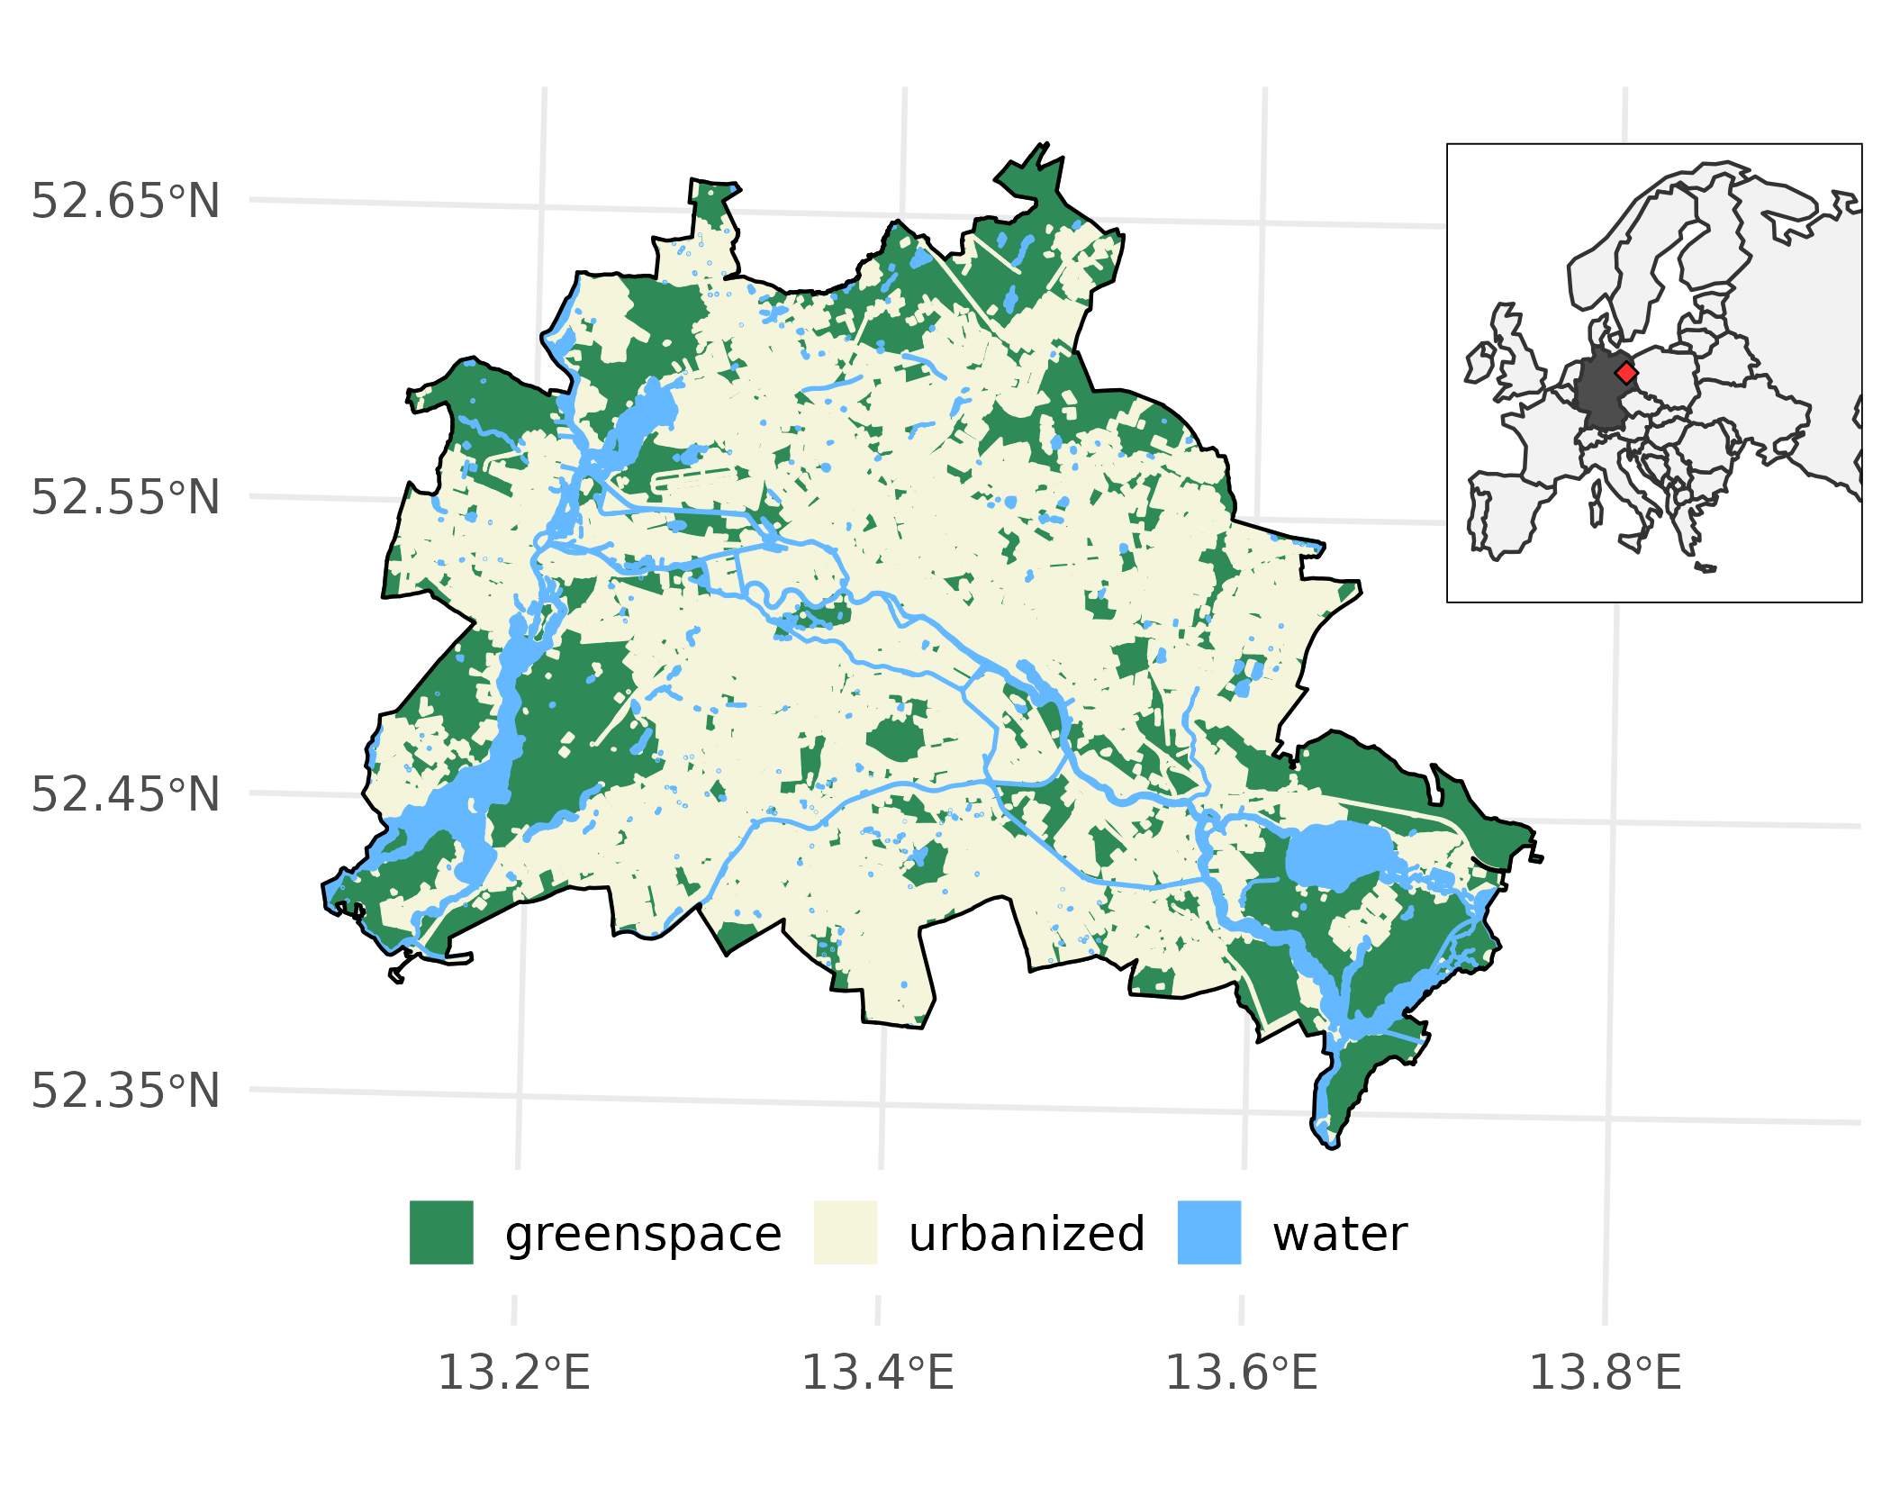

Figure 2.1: Berlin’s generalized land-use derived from SUVK, Berlin (2019) and location within the European context (inset).

## 2.2 General approach: space-for-time analyses

We modeled the stem diameter ($DBH$) of Berlin’s ten most abundant species (contingent to ancillary data availability) in relationship to their location, age, a measure of excess heat (UrbClim by De Ridder et al., 2015; Berlin Environmental Atlas models; LandSat-derived surface urban heat island by Chakraborty and Lee, 2019), and additional environmental covariates with generalized additive models (GAMs, see Section2.5 for details). Covariates were extracted at 150 and 300 $m$ to infer the impact of reference scale of the urban fabric on tree growth. From all tested models the most suitable (i.e., parsimonious with highest explanatory) was employed for further analyses.

## 2.3 Data sources

An overview of data used for models, including sources, types, and application, is provided in Table??, with detailed descriptions in the following subsections.

### 2.3.1 Street trees

Berlin’s open data provided tree inventories including species, age, location, and circumference which was transformed into diameter. Note that only street trees in urban, not rural areas or within green spaces, were considered here, but individual trees may grow along streets adjacent to green spaces and parks of varying sizes. Implausible observations, likely from erroneous data entry, were removed. Additional manual data processing for quality control was done with a bespoke software datacleanr by Hurley *et al*. (submitted), where obvious outliers or clearly interpolated data were removed; the latter was deemed necessary, as several observations in multiple city districts were derived by linear relationships (i.e., straight-line), which do not capture the ontogenic growth dynamics of trees, and leave no variation related to variables other than age. All of these operations were recorded, and can be viewed and reproduced via the supplementary code. Lastly, observations with unlikely diameter-age combinations were identified via the residuals of a generalized linear model between diameter and age with a Gamma log-link distribution: if individual residuals exceeded seven times the median absolute deviation of all residuals, they were removed. The median absolute deviation (MAD) is comparable to the inter-quartile range, yet more robust to outliers:

$$MAD=median(∥X_{i}−median(X)∥) (2.1)$$

This approach is considered conservative (see supplementary information), yet all analyses were carried forward with the unfiltered and filtered data - no considerable differences were found, thus subsequent sections are based on the filtered data. Table?? shows the binned distribution of genera across age classes. Final samples applied in models were smaller, following the availability of ancillary data for a given observation, and limited to a maximum age of 125 years to increase confidence in reported values, and ultimately model estimates.

### 2.3.2 Temperature/UHI data

Temperature and UHI data were summarized temporally either by the provider or manually to provide a characteristic representation of heat loading during summer at different times (morning, afternoon/day, night), from which tree averages (radius of 150 $m$) were calculated (Figure2.2). Two data sets of urban air and one surface temperature were tested as explanatory variables in GAM models. The air temperatures from the Berlin environmental atlas (EnvAt) are model outputs that are representations of typical summer conditions at 0400, 1400 and 2200 hours; these data are provided at city block basis (spatial polygons), from which weighted averages were extracted. UrbClim air temperatures are hourly model outputs (100 $m$ resolution, De Ridder et al., 2015) based on ERA5 re-analyses data (ECMWF) for which observations from the hottest month available (June, 2011) were averaged to hours equivalent to Berlin Environmental Atlas (referred to as Berlin EnvAt) data by using a window of $± 1$ hour (i.e., 0300 to 0500, etc.). Subsequently, a land-use and land-cover mask (CORINE; European Union, Copernicus Land Monitoring Service 2018, European Environment Agency) was used to define urban and rural/forested areas. Using this mask was deemed reasonable as Berlin’s built-up area has not changed markedly over the past 50 years, i.e., about 52 to 61 $\%$ (Mohamed, 2017). The urban heat loading was then calculated as

$$UHI_{x,y}=T_{Air_{2m} x,y}−\overline{T_{Air_{2m} Rural}}, (2.2)$$

where $T$ is temperature ($​^{∘}C$) $x$ and $y$ define an urban grid cell. The LandSat-derived surface UHI data set by Chakraborty and Lee (2019) (referred to as LandSat) estimates its measure in a similar fashion and the reader is referred to the detailed description therein; note this data set provides day and night-time averaged UHI estimates at 500 $m$ resolution, which were extracted for the hottest summer in this record (2007).

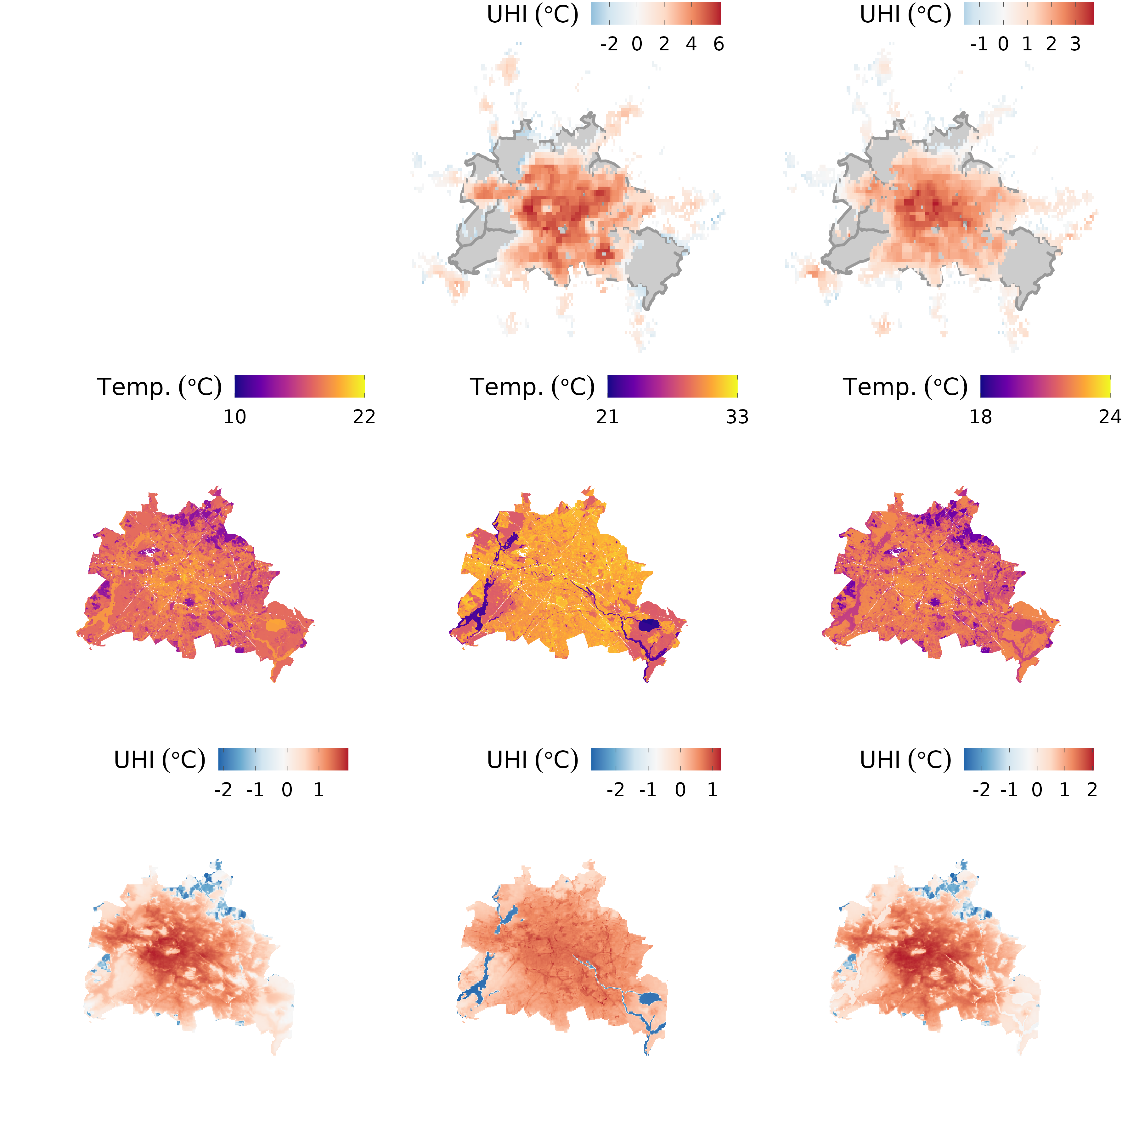

Figure 2.2: Temp overviews; rows are landsat, berlin environmental atlas, and UrbClim, columns are morning, day/afternoon, night. **ADD Labels for Data source and time of day at left and bottom**

### 2.3.3 Ancillary environmental data

Following the general approach described above, four ancillary covariates next to a temperature measure were employed in models; these were chosen due to their availability at high spatial resolution and coverage, and/or because their influence on growth was previously identified in literature or their likely impact could be deduced using ecophysiological principles. We included planting bed area and the sum of exchangeable basic cation as a proxy for soil nutrient availability (point extractions), as well as the proportional coverage of local climate zone 6 (LCZ6; open mid-rise, see Demuzere et al. (2019) and Stewart and Oke (2012) for details) and adjacent building height (spatial averages). The latter was chosen as an increase reflects a transition away from densely urbanized areas and had the highest coverage for the processed tree inventory.

## 2.4 Dendrochronological sampling

To contextualize tree growth patterns between age groups derived from Berlin’s inventory data, we drew upon a recently established data set from Schneider *et al.* (in review), who sampled several common tree species across a rural-urban gradient. For our purposes, we grouped trees sampled in parks, green spaces and along streets into a single urban category, and focused analyses on these. Two to three cores were extracted at breast height from each tree. These were then prepared using standard dendro-ecological methods (i.e., mounting, sanding, measuring), and cross-dated with TSAP-Win and COFECHA (Holmes et al., 1986), producing mean tree series of incremental growth. Additionally, cambial age of each increment was established by counting years from the inner most ring at the pith ($a=0$) outward; on tangentially bored cores, missing rings to the pith were estimated.

## 2.5 Statistical Analyses

### 2.5.1 GAMs

We applied hierarchical generalized additive models (GAM) to estimate the relationship of several covariates with stem diamater growth ($DBH$). GAMs, as an extension of generalized linear models (Wood, 2017), allow modeling response variables as parametric and non-parametric combinations of smoothed explanatory covariates, and can assume non-normal response distributions. These smooths are constructed by summation of base functions of varying complexity and form, analogous to scatterplot smoothing (Hastie and Tibshirani, 2017), which provides a high degree of flexibility, ideal for fitting ecosystem dynamics which are rarely linear (Pedersen et al., 2019), or correctly represented with deterministic functional forms (e.g. quadratic equations). In general, a GAM can be written as:

$$E(Y) = g^{−1}\left(β_{0}+\sum_{i=1}^{n}{f_{i}}(x_{i})\right), (2.3)$$

and

$$y = E(Y)+ϵ, (2.4)$$

where $Y$ is taken from an appropriate distribution and corresponding link function $g$, $β_{0}$ is the intercept and $f_{i}$ represents a smooth function of a predictor (Pedersen et al., 2019), and $ϵ∼N(0,σ^{2})$. Nested data structures (e.g., city districts) can be accounted for by introducing random effects, while spatial dependence between observations can be accounted for by constructing smoothing functions with, for instance, northings and eastings (cf. Wood, 2017). All models were implemented in R (R Core Team, 2021) using functions available in the package mgcv (Wood, 2017).

### 2.5.2 Dendrochronological analyses

We assessed trends in annual growth dynamics of urban trees across the 20 $​^{th}$ century for 1920-1960 and 1961-2001 Dahlhausen et al. (2018) with a hierarchical GAM implemented in mgcv::gamm() to leverage auto-correlation structures made available through the package nlme (Pinheiro et al., 2021). Annual growth was modeled as:

$$g(Δr_{i})=f(year_{i})+f_{j}(cambial age_{i})+c_{i,j}+τ_{i,k}+e_{i} (2.5)$$

where $g()$ is a log-link for $Δr∼Gamma$, $Δr$ is the annual radial increment for observation $i$. A global temporal (by year) and time-dependent ($j$, $≤1960$ or $>1960$) trend in cambial age were implemented with thin plate regression splines (default smoothing function in mgcv); $c_{j}$ is a time-group dependent intercept, while $tau$ represents a matrix of random effect coefficients for $k$ species to account for differences in growth patterns, and $e_{i}=ϕe_{i−1}+ϵ_{i}$. A $3^{rd}$-order autocorrelation-moving average (ARMA) correlation structure was applied (i.e., $ϕ(3,1)$) to account for the dependency of $Δr$ across years for each tree, as is frequently the case for tree growth (e.g., see Fritts and Swetnam, 1989); the detailed implementation for this model is given in the supplemental material code. $Δr$ was then derived for a range of cambial ages, and averaged for both time groups, allowing a comparison of recent to earlier growth. We acknowledge that tree cores obtained at breast height do not represent absolute tree age. However, here they serve as a proxy for growth between young ($⪆1960$) and older individuals to contextualize growth patterns inferred from the larger-scale tree inventory.

### 2.5.3 Stem diameter model development and selection

The diameter ($DBH$) of the ten most abundant species were modeled using GAMs as follows:

$$\begin{matrix}UHI_{x,y}=T_{Air_{2m} x,y}−\overline{T_{Air_{2m} Rural}}, (2.2)\end{matrix}$$

test

$$g(DBH_{i})=f(x_{i},y_{i})+f_{j}(age_{i})+f_{j}(temp_{t,i},age_{i})+f(covariate_{i})+c_{i,j}+τ_{i,k}+ϵ_{i}$$

$$g(DBH_{i})=f(x_{i},y_{i})+f_{j}(age_{i})+f_{j}(temp_{t,i},age_{i})+c_{i,j}+τ_{i,k}+ϵ_{i}$$

$$g(DBH_{i})=f(x_{i},y_{i})+f_{j}(age_{i})+f(covariate_{i})+c_{i,j}+τ_{i,k}+ϵ_{i}$$

$$g(DBH_{i})=f(x_{i},y_{i})+f_{j}(age_{i})+c_{i,j}+τ_{i,k}+ϵ_{i}$$

where $g()$ is a log-link for $DBH∼Gamma$, and $i$, $j$ are indices for observations and species, respectively, and $t$ refers to an (excess) heat measure from UrbClim, Berlin EnvAt or LandSat at different times (morning, afternoon/day, night; cf. Section2.3); $c$ is a species-dependent intercept, while $tau$ represents a matrix of random effect coefficients for $k$ districts to account for differing management regimes across the city. A global spatial smooth $f(x_{i},y_{i})$ (representing projected coordinates in UTM) via a Gaussian process (cf. p. 242 in Wood, 2017) was included to account for the spatial structure of observations, which reduced auto-correlation of model residuals considerably (see supplemental information). These were compared to a sub-set of models without a spatial component (cf. Equation(??), and Figure3.2 but not further discussed there). We also tested a suite of models without the spatial smooth for comparison **what’s the impact of remaining auto correlation? inflated errors, larger coefficients?**

Further, we implemented the interaction between temperature and age (i.e., $f_{j}(temp,age)$ as tensor smooths (Wood, 2006) to account for the different variable scales (i.e., units); all models were also tested without this interaction using a thin plate regression spline smooth for temperature (not shown in equations above). The functions $f_{j}$ are for species-specific smooths (i.e., with individual smoothness penalties and functional shapes as detailed by Pedersen et al., 2019). The covariates for planting bed area and soil nutrient availability were log transformed to account for their skewed distribution, improving the estimation of coefficients for their respective basis functions. Note, that Equation(??) was considered as the appropriate null model for interpretations. Models were implemented with mgcv::bam() (Li and Wood, 2020; Wood et al., 2017) and readers are referred to the detailed implementation in the supplemental material code.

Considering all combinations of (excess) heat measures and covariates (with point, as well as 150/300 $m$ extractions), a total of 158 models were applied. We selected the model with the highest explanatory power, based on residual deviance and observed vs. predicted fit, with comparatively largest sample size for final analyses. From this model we derived age and species dependent $DBH$ averages across a temperature measure from predicted values in 5-year age groups starting at 30, 45, 60, 75, 90.

As the spatial extent and coverage varied between temperature and ancillary data, more complex models (and specifically those including planting bed area and LandSat temperatures) typically also had fewer total observations. While this prevented a full comparison with information-based model selection criteria, such as Aikake’s (AIC), the appropriateness of models that differed only in their implementation of the temperature-age interaction (i.e., $f_{j}(temp_{i})$ $vs.$ $f_{j}(temp_{i},age_{i})$) could be assessed. For this reason, the suite of developed models presented above were limited to comparatively simple structures (i.e., few terms, interactions and restricted number of basis functions), reducing the potential for choosing over-fitted models without formal comparison. AIC is calculated as:

$$AIC=−2log(L)⋅2k$$

where $L$ is the maximum likelihood estimate, and $k$ is the number of parameters. Where any two comparable models had a $|ΔAIC|>10$, we considered the model with the lower score more suitable. Future research may focus on collecting additional data (e.g., increasing the coverage on planting bed area) and subsequently deriving species-specific smooths for ancillary environmental covariates. We chose to carry out the analysis in its current form rather than on considerably smaller but comparable sample sizes across models, to identify the strongest relationships in the existing data. This allowed us to highlight the utility of the approach *per se* and for Berlin in particular. **Measures used to asses goodness-of-fit were residual deviance, RSME and MAE (add formuals)**

# 3 Results

## 3.1 Growth trend dynamics

Recently established annual, incremental growth is on average greater as compared to earlier times (i.e., prior 1960; Figure3.1). The contrast is strongest in the first 30 years of cambial development, with clear indication that averages are statistically different up to approximately 22 years (cf. overlap of 95 $\%$ confidence intervals). The predicted trajectories for both periods follow typical ontogenetic patterns, yet differ in shape. This may be due to inaccurately estimated cambial ages, explaining the largely monotonic decrease for recent growth due to missing the typical (but not always present) initial rise and fall in pith-near stages. This would inadvertently create a left-shift in Figure3.1 for recent growth. Assuming that to be the case, the actual difference in average rates would be greater than presented here.

(ref:cambial-effect) Rates for annual incremental growth differ between recent and earlier times, as predicted by a hierarchical GAM (see Section2.4). Thick lines and bands are for mean and 95 $\%$ confidence interval of all annual predictions across a time group (fine lines). On average, early stages of recent growth (up to approximately 22 years) exceed that of earlier periods discernibly.

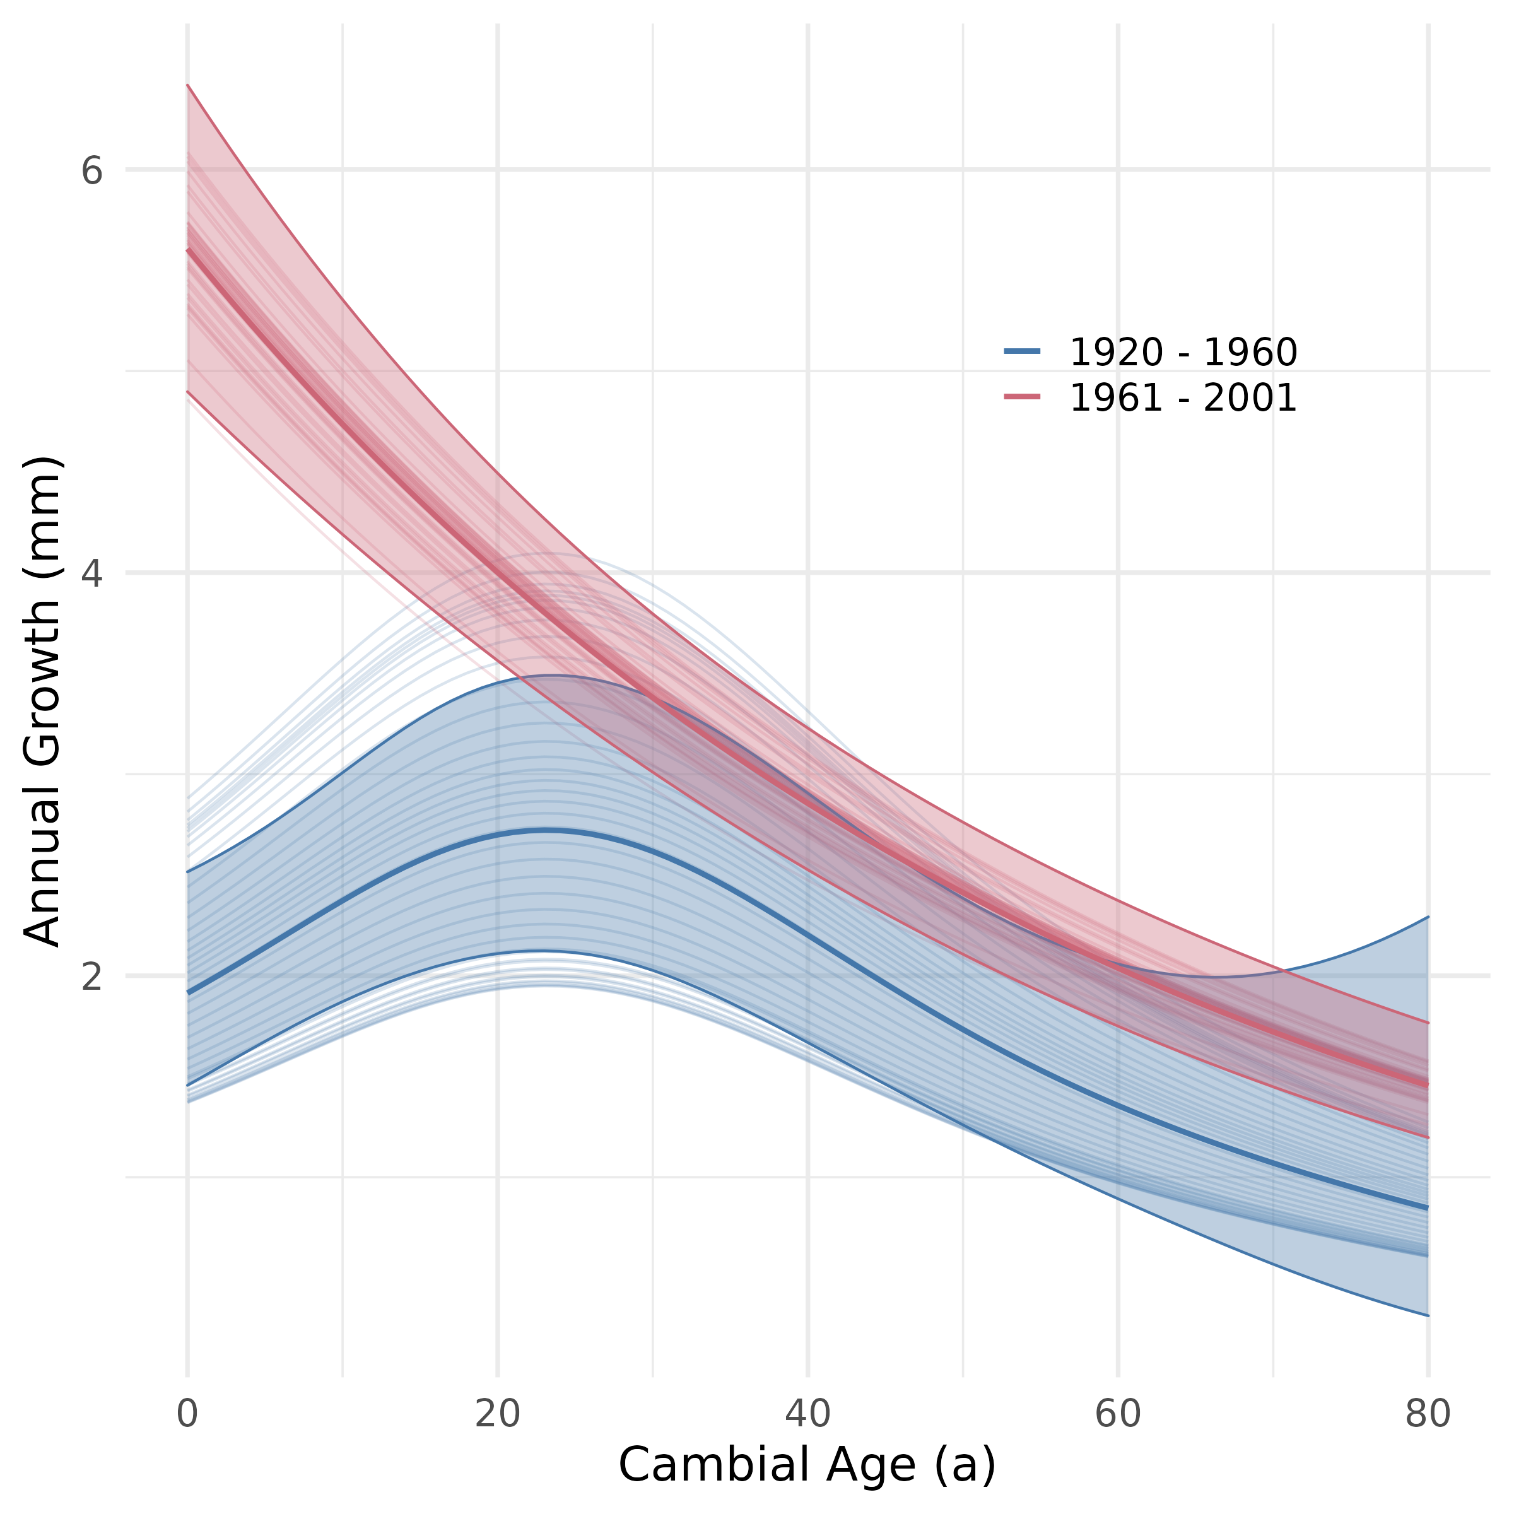

Figure 3.1: (ref:cambial-effect)

## 3.2 Model selection

* Null-model high, but for predictive purposes more is better
* Temperature-based models on average better than without, but planting bed area and lcz6 individually outperform - indication that these variables are indeed important; choice of best performing model, which includes lcz6, coroborated. *Landsat temp best on average - easily accessible/maintainable as compared to model outputs
* $lcz6_{150}$ vs. $lcz6_{300}$  - scale of impact (further investigation, note in discussion)
* building height, as a proxy for urban fabric and incoming radiation had minimal effect (regardless of 150/300)

(ref:model-deviance) Overview of model fit, expressed as explained deviance, for all tested models. The Panels distinguish between models without (top) and with (bottom) spatial smooths to account for autocorrelation of residuals. Colored sub-sections define models without and with the applied (excess) heat measures. Symbols identify models with an interaction between temperature and age (diamond), and without (circle), while colors highlight included covariates and their reference radius (i.e. 150/300 $m$, but also note x-axis labels), and size indicates the model’s observations. Generally, including temperature (interactions) improve model fits above the null-model (age only), and excluding planting bed area and LCZ6 cover, also above other non-temperature models. The LandSat-derived UHI measures provide the best fit on average, with the model including a temperature-age interaction and LCZ6 cover scoring highest.

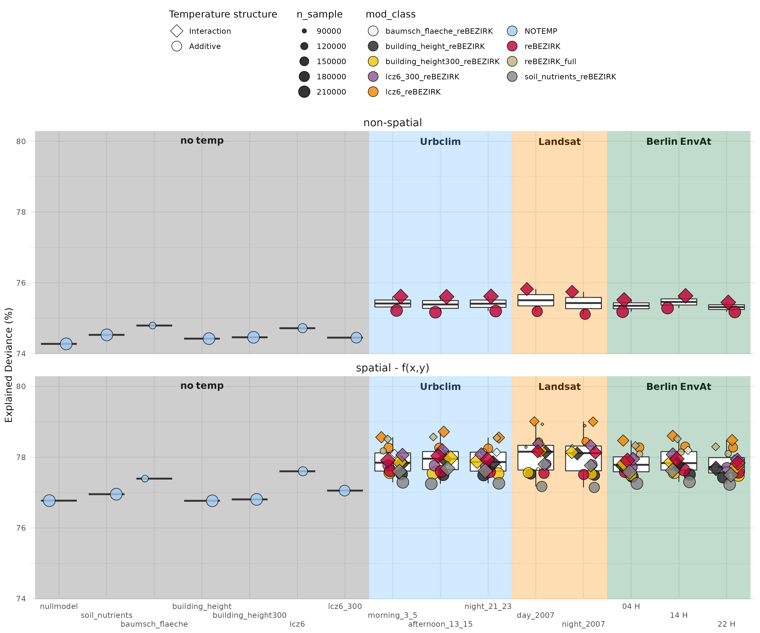

Figure 3.2: (ref:model-deviance)

**Add table with ANOVA for interaction, non-interaction and MAE/RSME**

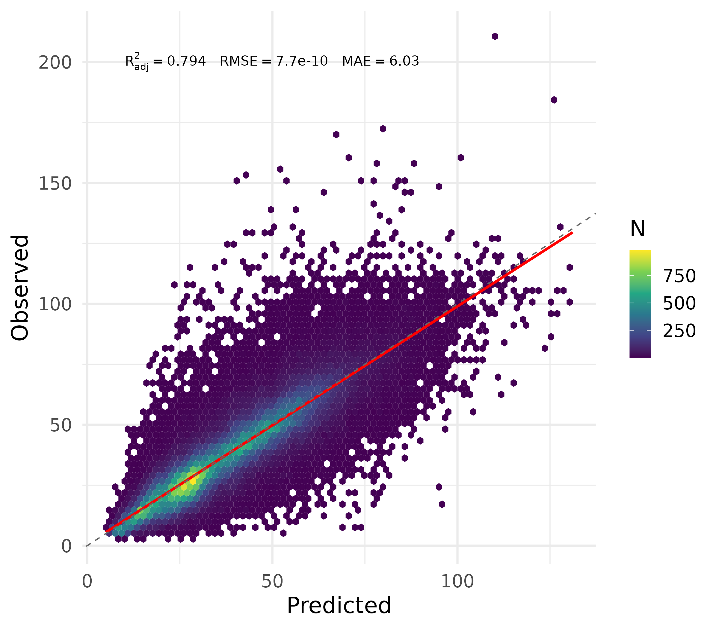

Figure 3.3: Predicted vs. observed best model day2007 and LCZ6

## 3.3 Urban heat and urban fabric effects on stem growth

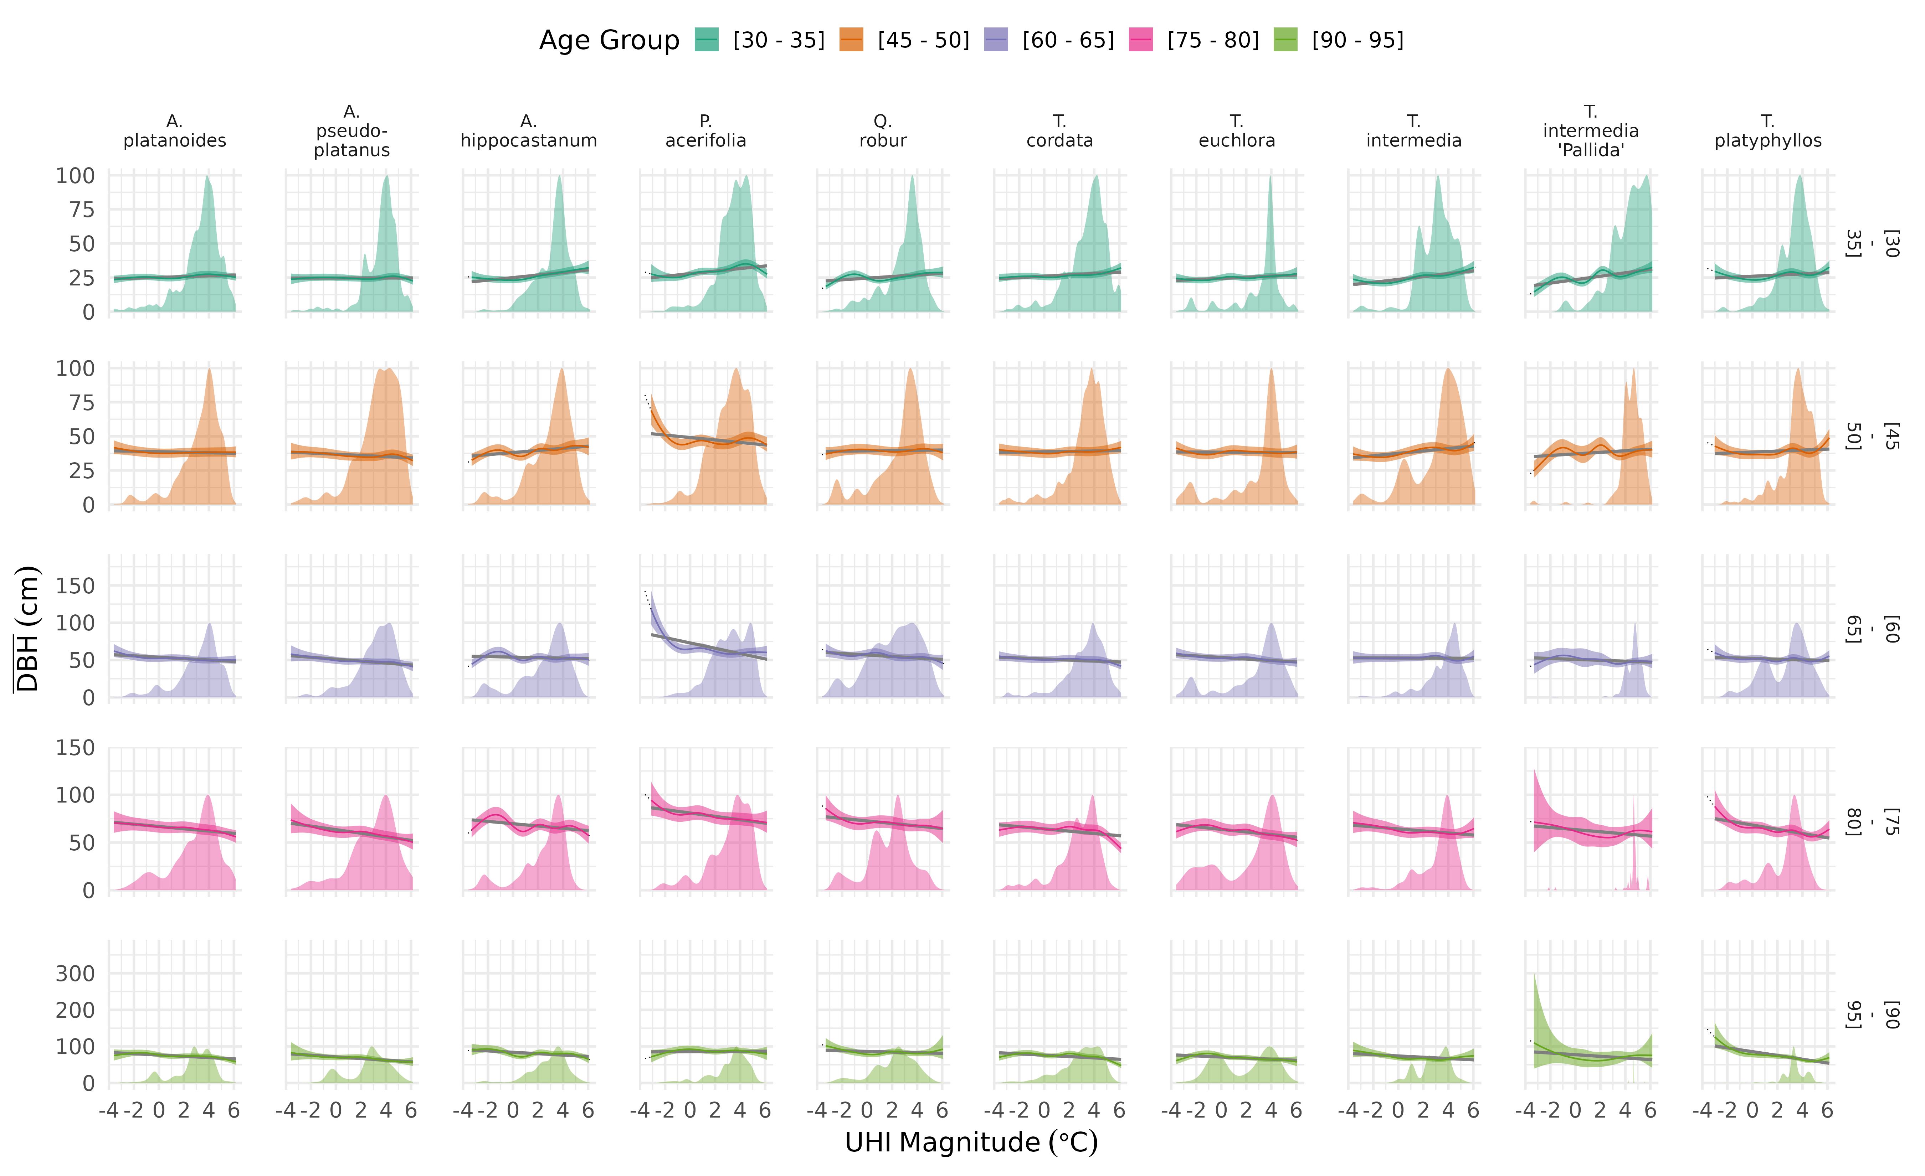

Figure 3.4: Age group-dependent temperature effect; only within range

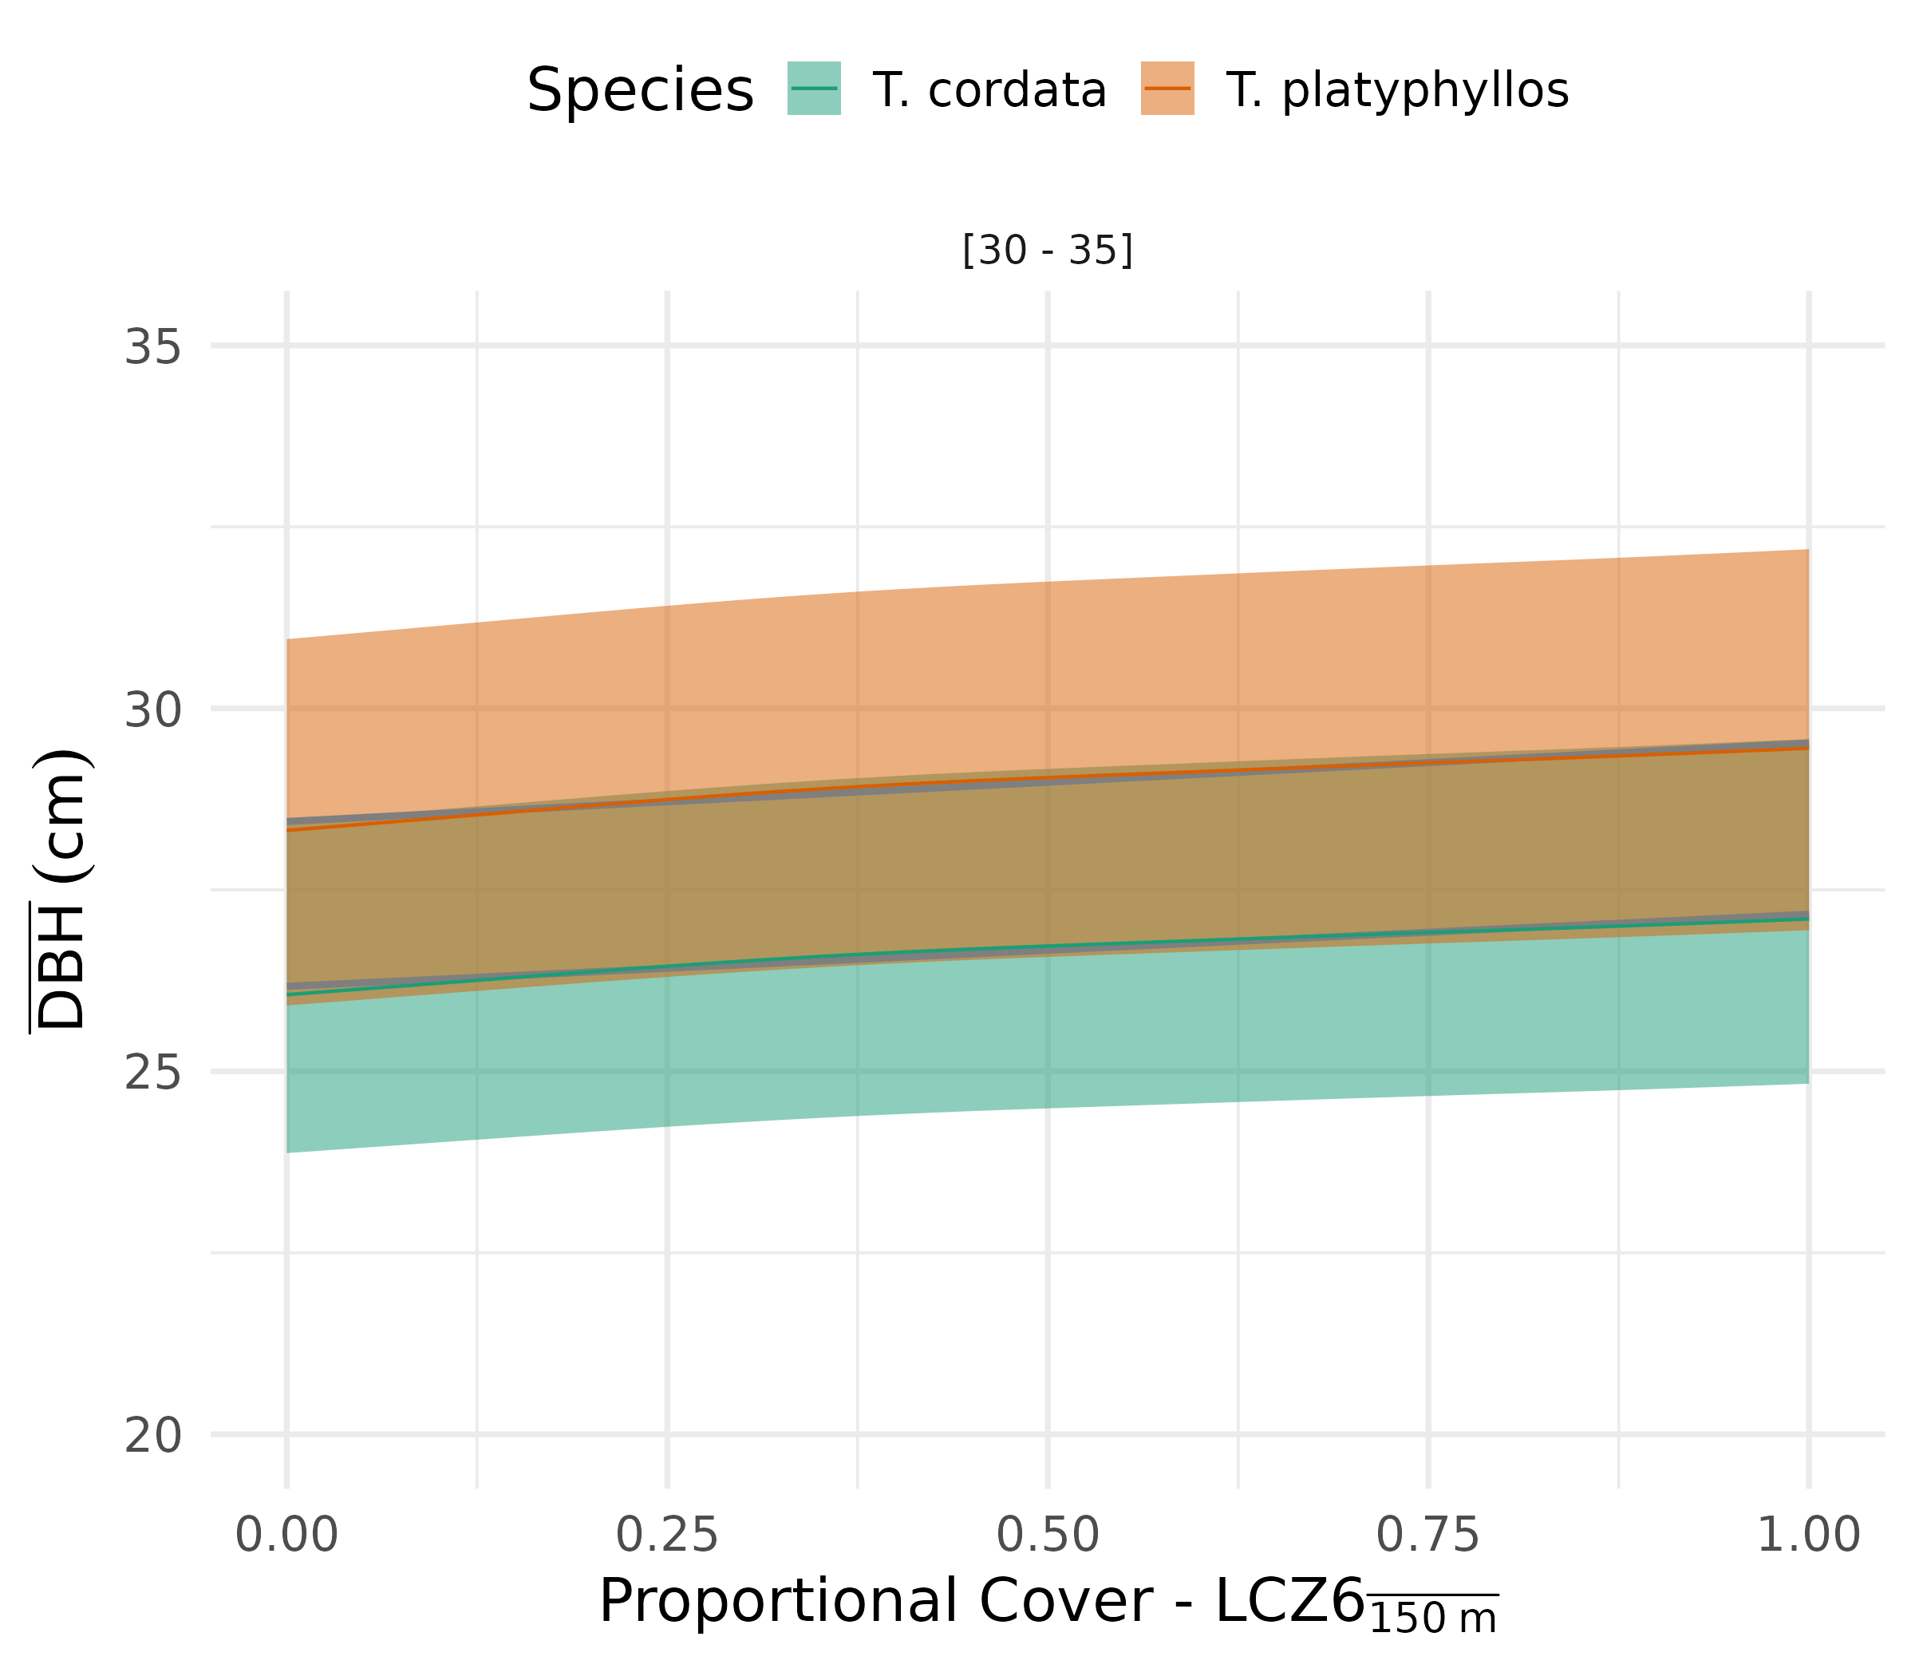

Figure 3.5: Global effect of LCZ6 on growth

## 3.4 Exposed trees

**Add figure with tree locations where growth is below the average - color = UHI?**

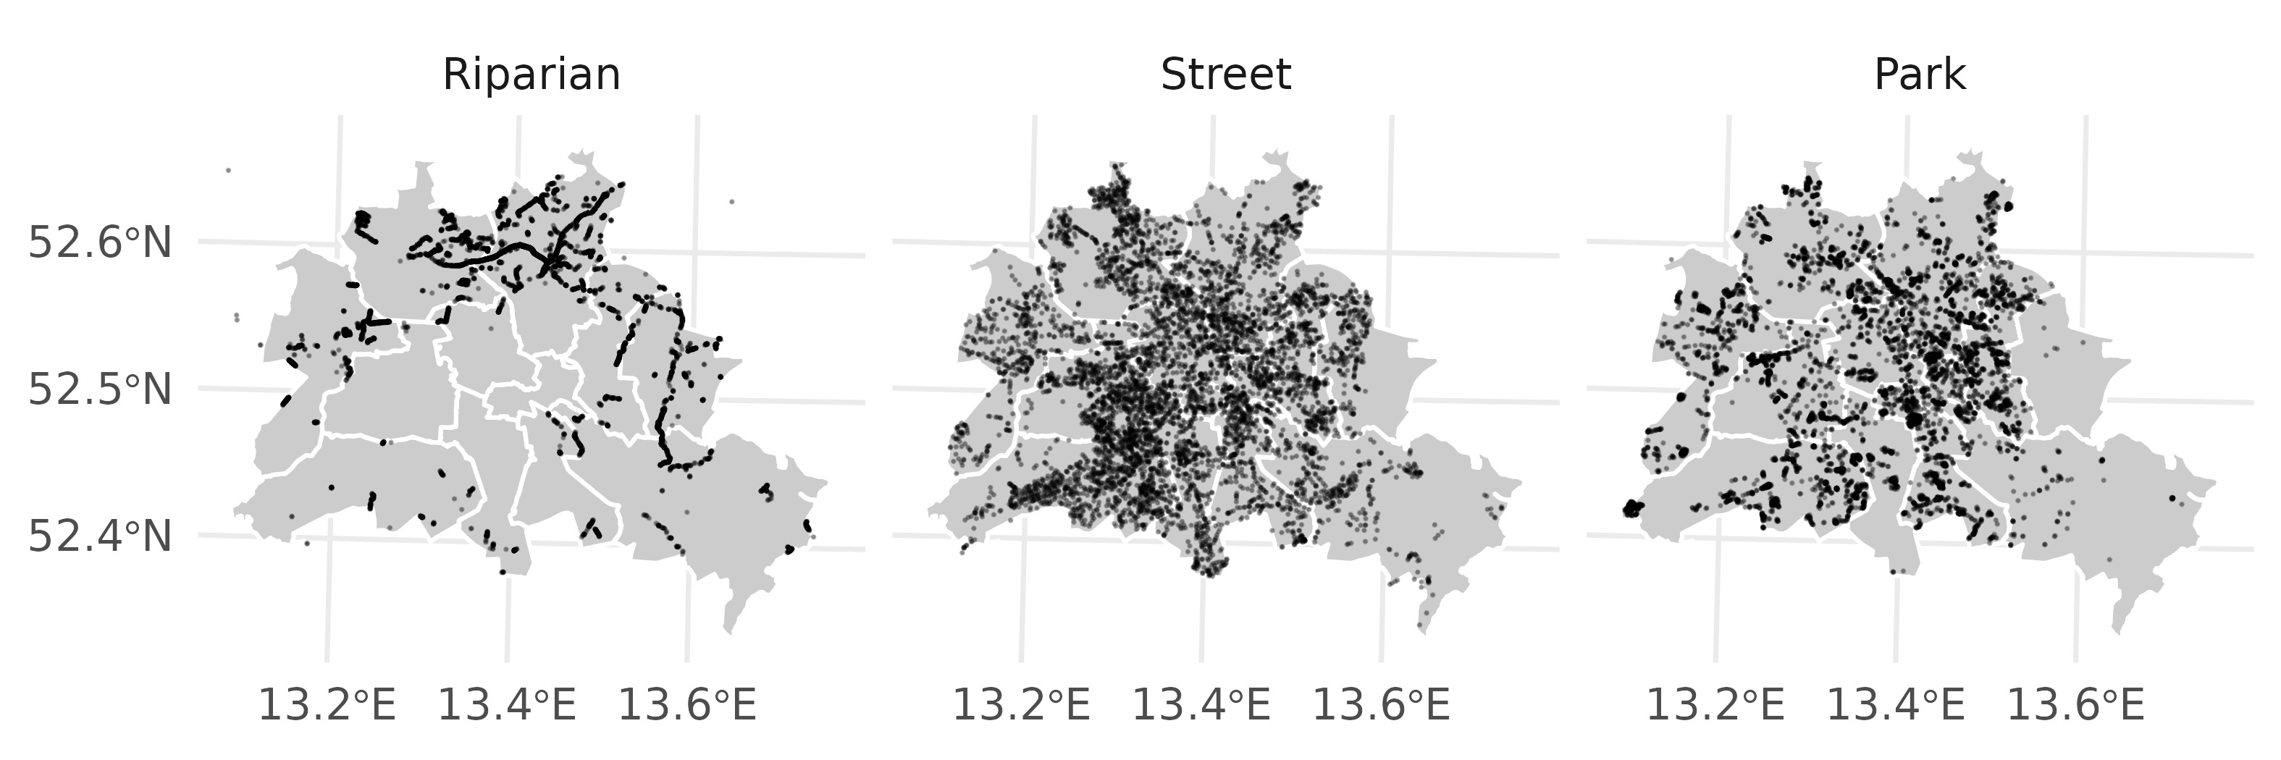

Figure 3.6: Individual tree locations for three categories available in Berlin Senate urban tree data set. Note, that for each category 7000 observations were subsampled from the available pool to facilitate visualization.

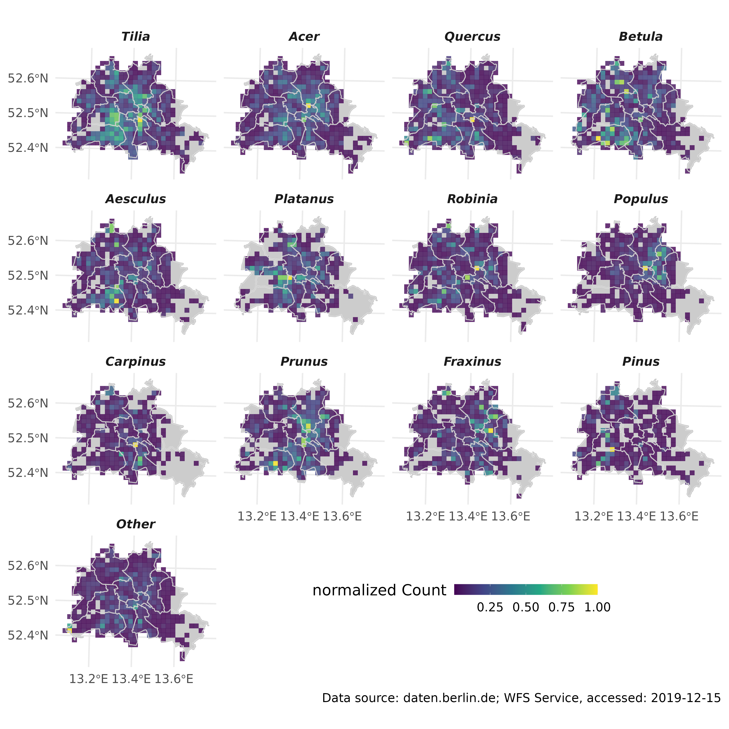

Figure 3.7: Gridded counts for the 11 most frequent genera, as well as *Pinus* and remaining genera. Note, that counts are standardized to unity for individual genera.

The distribution of the UHI effect is highly irregular and clustered in space (Fig.3.8), and also shows variability through time (data not shown, refer to the [urban heat island explorer](https://yceo.users.earthengine.app/view/uhimap)).

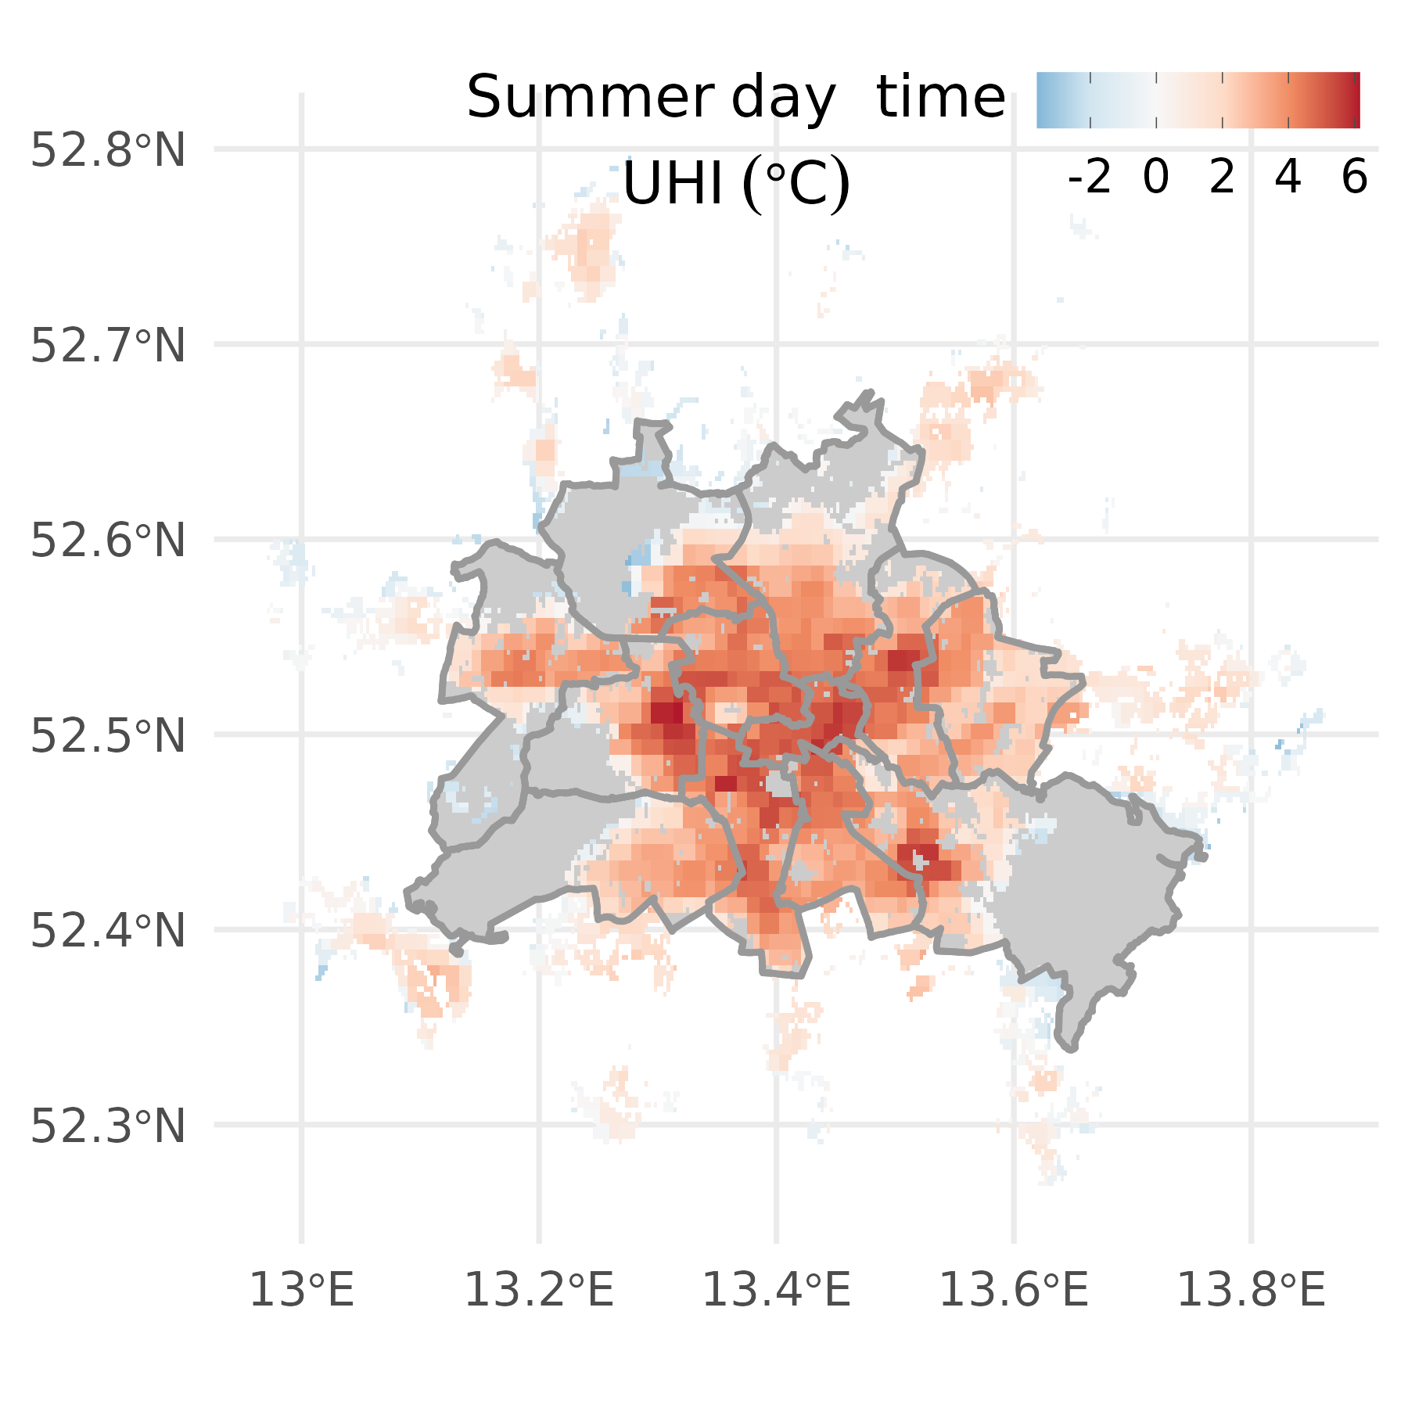

Figure 3.8: Estimate of UHI intensity based on the algorithm in (Chakraborty and Lee, 2019), comparing urban with rural pixels within the greater metropolitan cluster. Presented values are averaged over the summer of 2007.

The exposure to increased heat-loading of individual genera (and consequently species) is highly uneven throughout the city (Fig.3.9). Street and park trees of most genera are clustered in urban areas with intermediate to high UHI loading, while riparian trees, and some street and park trees of other genera tend to be spread more evenly across Berlin’s UHI range.

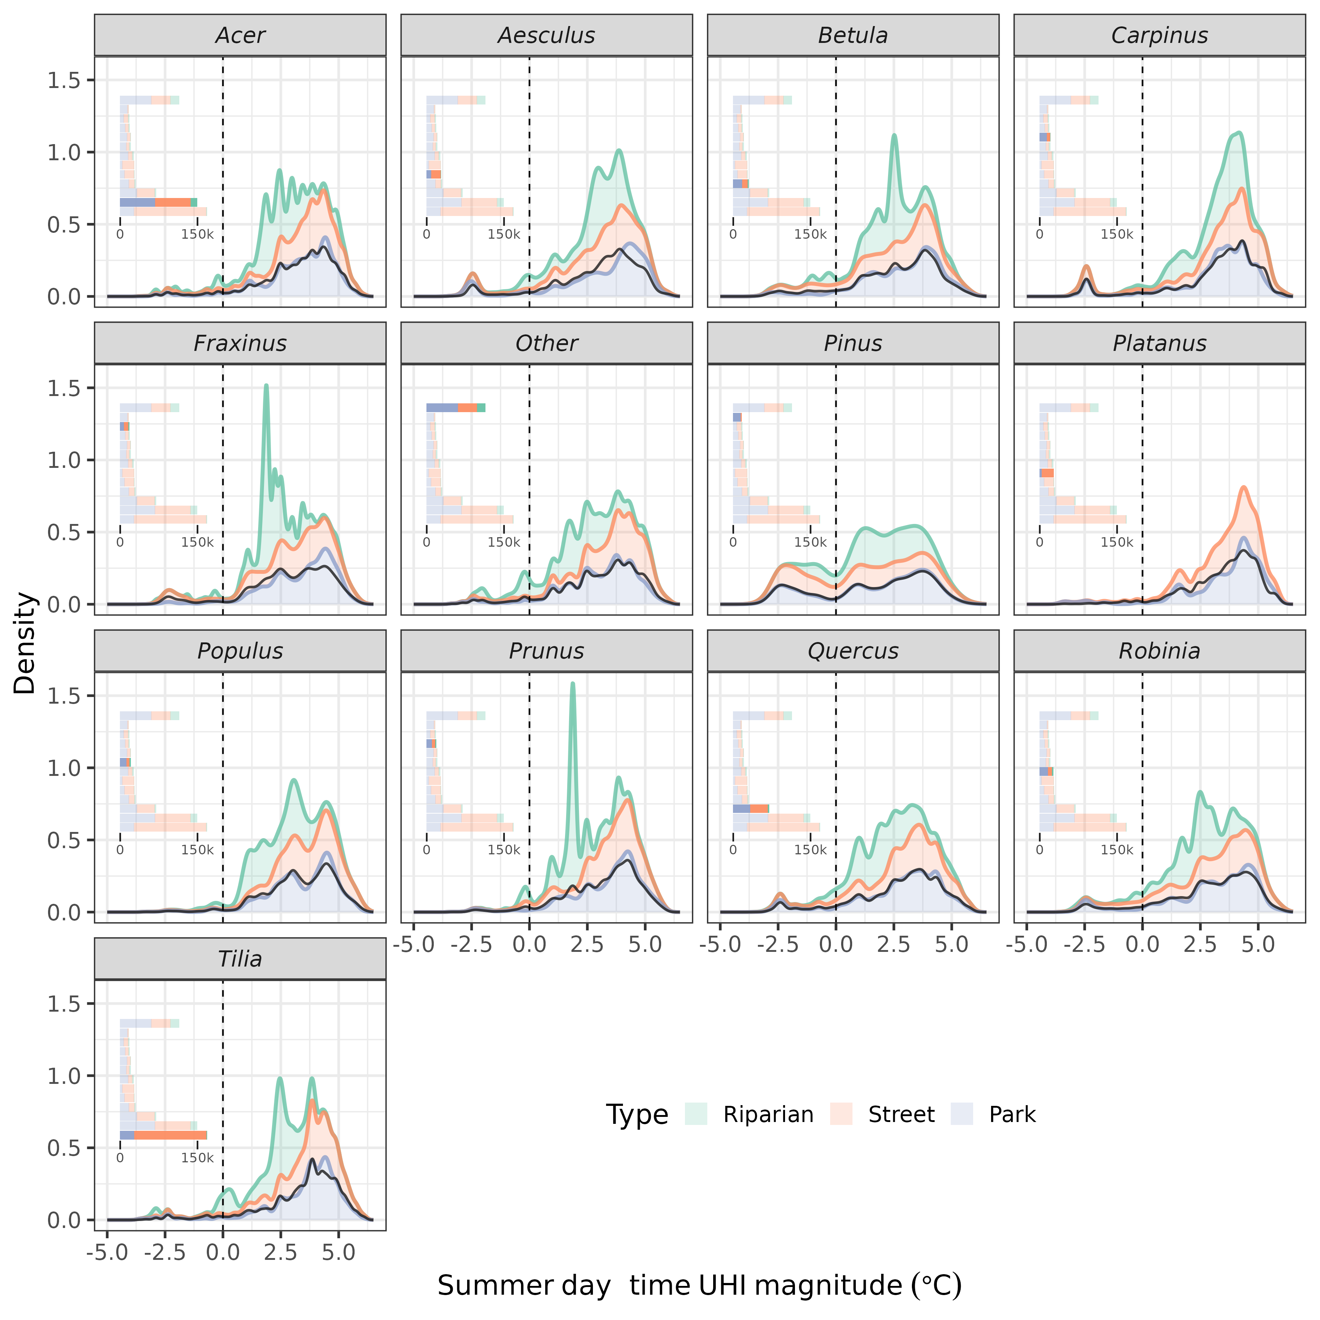

Figure 3.9: Empirical density distribution of all individuals within the presented genera along the UHI continuum. UHI intensities were extracted for each tree location, and the distribution hence represents the first detailed overview of the exposure of Berlin’s trees to urban heat loading. The black line is the density across all three categories. Insets show corresponding tree totals.

**Note, that results below are preliminary and should be considered as a template for future outputs, rather than used for inference.** The effect of UHI loading on absolute growth potential varies between genera and species (Fig.3.10). Most notably, *Quercus*, the 3rd-most frequent genera, shows decreased absolute growth with increasing UHI loading, while the most frequent genera, *Tilia*, features contrasting relationships between species. The estimated effect sizes presented here are linear. However, temperature may exert a non-linear control on absolute growth and, hence, applying a method able to capture such dynamics may result in somewhat different effect sizes / behavior. Additionally, if temperatures increase in the future under climate warming, any non-linear effects may become more enhanced, stressing the need for a more flexible model fit and structure (i.e. using GAMM over linear models-).

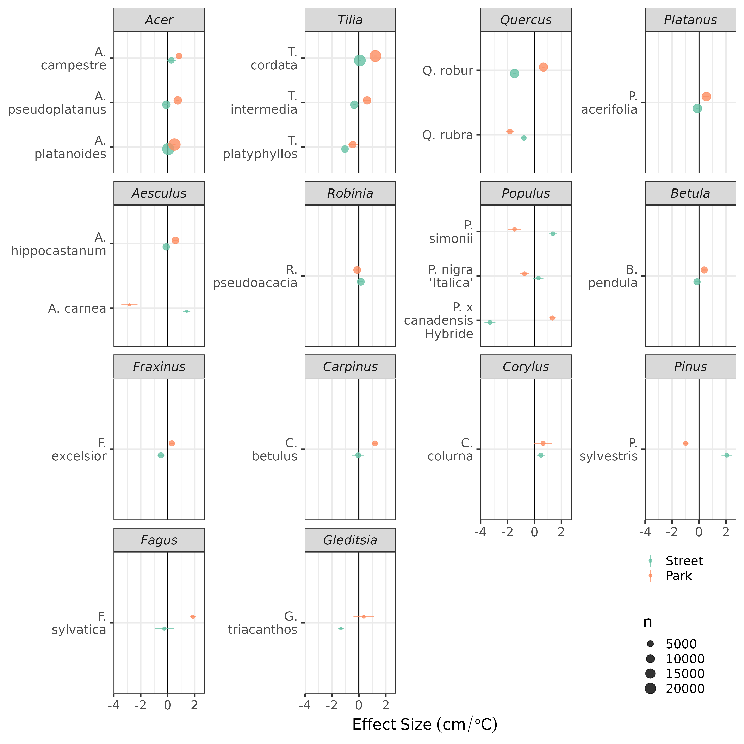

Figure 3.10: Impact of UHI loading on tree diameter ($DBH$), accounting for age and inter-specific differences from the linear mixed model (via random slopes and intercepts). Line-ranges are standard errors of predicted effect sizes (i.e. slopes). Differences between street and park trees are considerable for some species, and may be due to local clustering and/or spatial under-representation across the UHI continuum. Further investigations need to address the degree of spatial autocorrelation and account for it where required in linear mixed models, and with smoothing interactions in a GAMM implementation.

# 4 Discussion

1. Temperature, environmental and urban controls on tree growth
   * Intra specific differences
     + management
     + root vs. canopy (huber value?)
     + accelerated recent growth
     + comparison young vs. old -> increased CO2, perhaps limitation of space for time, as lower conductance under high CO2 may result in more water savings (check WUE in old vs. young trees? future direction).(Dusenge et al., 2019) (McCarthy et al., 2011)
   * Sensitive trees in hot spots
   * Temporal dynamics
   * Validity and limitations

* (Bussotti et al., 2014)

1. Implications:

* Policy / planning:
  + tree species
    - Increase temporal coverage and accuracy
      * which trees to prioritize for measurement campaigns
      * Supplement species matrix etc. with these analyses
* Open data important –> drives innovation

# 5 Outlook

We seek to build upon and improve the current analysis by:

* validating the database with independent observations
* incorporating more pertinent covariates as dependent variables in the linear mixed model
* testing multiple model structures with formal model selection procedures
* checking model residuals for spatial auto-correlation and accounting for it where necessary to ensure unbiased estimates of effect sizes
* repeating the above with a hierarchical GAM (i.e. GAMM) to allow for:
  + estimating continuous prediction surfaces for UHI impacts on individual species’ growth (similar to results in Figure3.10) under recent conditions
  + estimating absolute, species-specific growth potential under increased temperatures and UHI loading under climate change, ideally based on climate simulations (otherwise step-wise increases based on RCP scenarios) for the key species. Note, that complications presented by ‘out-of-sample’ predictions will be addressed.
  + assess potential age-dependent UHI impacts on individual species.
  + repeating the above (GAMM) with total and incremental basal area as responses

# 6 References

Akbari, H., Pomerantz, M., Taha, H., 2001. Cool surfaces and shade trees to reduce energy use and improve air quality in urban areas. Solar Energy, Urban Environment 70, 295–310. <https://doi.org/10.1016/S0038-092X(00)00089-X>

Arcus, V.L., Prentice, E.J., Hobbs, J.K., Mulholland, A.J., Van der Kamp, M.W., Pudney, C.R., Parker, E.J., Schipper, L.A., 2016. On the Temperature Dependence of Enzyme-Catalyzed Rates. Biochemistry 55, 1681–1688. <https://doi.org/10.1021/acs.biochem.5b01094>

Au, K.N., 2018. An integrated approach to tree stress monitoring. Arborist News, International Society of Arboriculture 27, 28–31.

Beck, H.E., Zimmermann, N.E., McVicar, T.R., Vergopolan, N., Berg, A., Wood, E.F., 2018. Present and future Köppen-Geiger climate classification maps at 1-km resolution. Scientific Data 5, 180214. <https://doi.org/10.1038/sdata.2018.214>

Begum, S., Nakaba, S., Yamagishi, Y., Oribe, Y., Funada, R., 2013. Regulation of cambial activity in relation to environmental conditions: Understanding the role of temperature in wood formation of trees. Physiologia Plantarum 147, 46–54. <https://doi.org/10.1111/j.1399-3054.2012.01663.x>

Briber, B.M., Hutyra, L.R., Reinmann, A.B., Raciti, S.M., Dearborn, V.K., Holden, C.E., Dunn, A.L., 2015. Tree Productivity Enhanced with Conversion from Forest to Urban Land Covers. PLOS ONE 10, e0136237. <https://doi.org/10.1371/journal.pone.0136237>

Brune, M., 2016. Urban trees under climate change. Potential impacts of dry spells and heat waves in three German regions in the 2050s (No. Report 24). Climate Service Center Germany, Hamburg.

Bussotti, F., Pollastrini, M., Killi, D., Ferrini, F., Fini, A., 2014. Ecophysiology of urban trees in a perspective of climate change. Agrochimica 58, 247–268.

Chakraborty, T., Lee, X., 2019. A simplified urban-extent algorithm to characterize surface urban heat islands on a global scale and examine vegetation control on their spatiotemporal variability. International Journal of Applied Earth Observation and Geoinformation 74, 269–280. <https://doi.org/10.1016/j.jag.2018.09.015>

Dahlhausen, J., Rötzer, T., Biber, P., Uhl, E., Pretzsch, H., 2018. Urban climate modifies tree growth in Berlin. Int J Biometeorol 62, 795–808. <https://doi.org/10.1007/s00484-017-1481-3>

De Ridder, K., Lauwaet, D., Maiheu, B., 2015. UrbClim – A fast urban boundary layer climate model. Urban Climate 12, 21–48. <https://doi.org/10.1016/j.uclim.2015.01.001>

Demuzere, M., Bechtel, B., Middel, A., Mills, G., 2019. Mapping Europe into local climate zones. PLOS ONE 14, e0214474. <https://doi.org/10.1371/journal.pone.0214474>

Dusenge, M.E., Duarte, A.G., Way, D.A., 2019. Plant carbon metabolism and climate change: Elevated CO2 and temperature impacts on photosynthesis, photorespiration and respiration. New Phytologist 221, 32–49. <https://doi.org/10.1111/nph.15283>

Endlicher, W., Scherer, D., Büter, B., Kuttler, W., Mathey, J., Schneider, C., 2016. Stadtnatur fördert gutes Stadtklima, in: Ökosystemleistungen in Der Stadt – Gesundheit Schützen Und Lebensqualität Erhöhen, 3.1. TEEB DE. TU Berlin, UFZ Leipzig, Berlin, Leipzig, pp. 51–63.

Fatichi, S., Leuzinger, S., Körner, C., 2014. Moving beyond photosynthesis: From carbon source to sink-driven vegetation modeling. New Phytologist 201, 1086–1095. <https://doi.org/10.1111/nph.12614>

Fenner, D., Meier, F., Scherer, D., Polze, A., 2014. Spatial and temporal air temperature variability in Berlin, Germany, during the years 2001–2010. Urban Climate, ICUC8: The 8th International Conference on Urban Climate and the 10th Symposium on the Urban Environment 10, 308–331. <https://doi.org/10.1016/j.uclim.2014.02.004>

Fritts, H.C., Swetnam, T.W., 1989. Dendroecology: A tool for evaluating variations in past and present forest environments. Advances in ecological research 19, 111–188.

Geange, S.R., Arnold, P.A., Catling, A.A., Coast, O., Cook, A.M., Gowland, K.M., Leigh, A., Notarnicola, R.F., Posch, B.C., Venn, S.E., Zhu, L., Nicotra, A.B., 2021. The thermal tolerance of photosynthetic tissues: A global systematic review and agenda for future research. New Phytologist 229, 2497–2513. <https://doi.org/10.1111/nph.17052>

Gillner, S., Bräuning, A., Roloff, A., 2014. Dendrochronological analysis of urban trees: Climatic response and impact of drought on frequently used tree species. Trees 28, 1079–1093. <https://doi.org/10.1007/s00468-014-1019-9>

Gillner, S., Vogt, J., Tharang, A., Dettmann, S., Roloff, A., 2015. Role of street trees in mitigating effects of heat and drought at highly sealed urban sites. Landscape and Urban Planning 143, 33–42. <https://doi.org/10.1016/j.landurbplan.2015.06.005>

Grimmond, C., Souch, C., Hubble, M., 1996. Influence of tree cover on summertime surface energy balance fluxes, San Gabriel Valley, Los Angeles. Clim. Res. 6, 45–57. <https://doi.org/10.3354/cr006045>

Grossiord, C., Buckley, T.N., Cernusak, L.A., Novick, K.A., Poulter, B., Siegwolf, R.T.W., Sperry, J.S., McDowell, N.G., 2020. Plant responses to rising vapor pressure deficit. New Phytologist 226, 1550–1566. <https://doi.org/10.1111/nph.16485>

Gulyás, Á., Unger, J., Matzarakis, A., 2006. Assessment of the microclimatic and human comfort conditions in a complex urban environment: Modelling and measurements. Building and Environment 41, 1713–1722. <https://doi.org/10.1016/j.buildenv.2005.07.001>

Hansen, R., Olafsson, A.S., van der Jagt, A.P.N., Rall, E., Pauleit, S., 2019. Planning multifunctional green infrastructure for compact cities: What is the state of practice? Ecological Indicators, From urban sprawl to compact green cities – indicators for multi-scale and multi-dimensional analysis 96, 99–110. <https://doi.org/10.1016/j.ecolind.2017.09.042>

Hastie, T.J., Tibshirani, R.J., 2017. Generalized additive models. Routledge.

Hertel, D., Schlink, U., 2019. Decomposition of urban temperatures for targeted climate change adaptation. Environmental Modelling & Software 113, 20–28. <https://doi.org/10.1016/j.envsoft.2018.11.015>

Hilbert, D.R., Roman, L.A., Koeser, A.K., Vogt, J., Doorn, N.S.0pt0pt0pt0pt. van, 2019. Urban tree mortality: What the literature shows us. Arborist News.0pt0pt0pt0pt Oct: 22-26. Oct, 22–26.

Holmes, R.L., Adams, R.K., Fritts, H.C., 1986. Tree-ring chronologies of western North America: California, eastern Oregon and northern Great Basin with procedures used in the chronology development work including users manuals for computer programs COFECHA and ARSTAN.

Hoyano, A., 1988. Climatological uses of plants for solar control and the effects on the thermal environment of a building. Energy and Buildings 11, 181–199. <https://doi.org/10.1016/0378-7788(88)90035-7>

Jia, W., Zhao, S., Liu, S., 2018. Vegetation growth enhancement in urban environments of the Conterminous United States. Global Change Biology 24, 4084–4094. <https://doi.org/10.1111/gcb.14317>

Körner, C., 2015. Paradigm shift in plant growth control. Current Opinion in Plant Biology 25, 107–114. <https://doi.org/10.1016/j.pbi.2015.05.003>

Kuttler, W., Miethke, A., Dütemeyer, D., Barlag, A.-B. (Eds.), 2015. Das klima von essen = the climate of essen. Westarp Wiss., Hohenwarsleben.

Li, Z., Wood, S.N., 2020. Faster model matrix crossproducts for large generalized linear models with discretized covariates. Stat Comput 30, 19–25. <https://doi.org/10.1007/s11222-019-09864-2>

Long, S.P., 1991. Modification of the response of photosynthetic productivity to rising temperature by atmospheric CO2 concentrations: Has its importance been underestimated? Plant, Cell & Environment 14, 729–739. <https://doi.org/10.1111/j.1365-3040.1991.tb01439.x>

Mayer, H., Höppe, P., 1987. Thermal comfort of man in different urban environments. Theor Appl Climatol 38, 43–49. <https://doi.org/10.1007/BF00866252>

McCarthy, H.R., Pataki, D.E., Jenerette, G.D., 2011. Plant water-use efficiency as a metric of urban ecosystem services. Ecological Applications 21, 3115–3127. <https://doi.org/10.1890/11-0048.1>

McDowell, N., Pockman, W.T., Allen, C.D., Breshears, D.D., Cobb, N., Kolb, T., Plaut, J., Sperry, J., West, A., Williams, D.G., Yepez, E.A., 2008. Mechanisms of plant survival and mortality during drought: Why do some plants survive while others succumb to drought? New Phytologist 178, 719–739. <https://doi.org/10.1111/j.1469-8137.2008.02436.x>

Mohamed, M.A., 2017. Monitoring of Temporal and Spatial Changes of Land Use and Land Cover in Metropolitan Regions through Remote Sensing and GIS. NR 08, 353–369. <https://doi.org/10.4236/nr.2017.85022>

Monteiro, R., Ferreira, J.C., Antunes, P., 2020. Green Infrastructure Planning Principles: An Integrated Literature Review. Land 9, 525. <https://doi.org/10.3390/land9120525>

Moser-Reischl, A., Rahman, M.A., Pauleit, S., Pretzsch, H., Rötzer, T., 2019. Growth patterns and effects of urban micro-climate on two physiologically contrasting urban tree species. Landscape and Urban Planning 183, 88–99. <https://doi.org/10.1016/j.landurbplan.2018.11.004>

Norton, B.A., Coutts, A.M., Livesley, S.J., Harris, R.J., Hunter, A.M., Williams, N.S.G., 2015. Planning for cooler cities: A framework to prioritise green infrastructure to mitigate high temperatures in urban landscapes. Landscape and Urban Planning 134, 127–138. <https://doi.org/10.1016/j.landurbplan.2014.10.018>

O’Brien, A.M., Ettinger, A.K., HilleRisLambers, J., 2012. Conifer growth and reproduction in urban forest fragments: Predictors of future responses to global change? Urban Ecosyst 15, 879–891. <https://doi.org/10.1007/s11252-012-0250-7>

Oke, T.R., 1992. Boundary Layer Climates. Routledge, London; New York.

Oke, T.R., 1982. The energetic basis of the urban heat island. Quarterly Journal of the Royal Meteorological Society 108, 1–24. <https://doi.org/10.1002/qj.49710845502>

Ossola, A., Hoeppner, M.J., Burley, H.M., Gallagher, R.V., Beaumont, L.J., Leishman, M.R., 2020. The Global Urban Tree Inventory: A database of the diverse tree flora that inhabits the world’s cities. Global Ecology and Biogeography 29, 1907–1914. <https://doi.org/10.1111/geb.13169>

Parent, B., Turc, O., Gibon, Y., Stitt, M., Tardieu, F., 2010. Modelling temperature-compensated physiological rates, based on the co-ordination of responses to temperature of developmental processes. Journal of Experimental Botany 61, 2057–2069. <https://doi.org/10.1093/jxb/erq003>

Pauleit, S., Jones, N., Garcia-Martin, G., Garcia-Valdecantos, J.L., Rivière, L.M., Vidal-Beaudet, L., Bodson, M., Randrup, T.B., 2002. Tree establishment practice in towns and cities – Results from a European survey. Urban Forestry & Urban Greening 1, 83–96. <https://doi.org/10.1078/1618-8667-00009>

Pedersen, E.J., Miller, D.L., Simpson, G.L., Ross, N., 2019. Hierarchical generalized additive models in ecology: An introduction with mgcv. PeerJ 7, e6876. <https://doi.org/10.7717/peerj.6876>

Peters, R.L., Steppe, K., Cuny, H.E., De Pauw, D.J.W., Frank, D.C., Schaub, M., Rathgeber, C.B.K., Cabon, A., Fonti, P., 2021. Turgor – a limiting factor for radial growth in mature conifers along an elevational gradient. New Phytologist 229, 213–229. <https://doi.org/10.1111/nph.16872>

Pinheiro, J., Bates, D., DebRoy, S., Sarkar, D., R Core Team, 2021. Nlme: Linear and nonlinear mixed effects models.

Pretzsch, H., Biber, P., Uhl, E., Dahlhausen, J., Schütze, G., Perkins, D., Rötzer, T., Caldentey, J., Koike, T., Con, T. van, Chavanne, A., Toit, B. du, Foster, K., Lefer, B., 2017. Climate change accelerates growth of urban trees in metropolises worldwide. Scientific Reports 7, 1–10. <https://doi.org/10.1038/s41598-017-14831-w>

Quigley, M.F., 2004. Street trees and rural conspecifics: Will long-lived trees reach full size in urban conditions? Urban Ecosystems 7, 29–39. <https://doi.org/10.1023/B:UECO.0000020170.58404.e9>

R Core Team, 2021. R: A language and environment for statistical computing. R Foundation for Statistical Computing, Vienna, Austria.

Randrup, T.B., McPherson, E.G., Costello, L.R., 2001. A review of tree root conflicts with sidewalks, curbs, and roads. Urban Ecosystems 5, 209–225. <https://doi.org/10.1023/A:1024046004731>

Rathgeber, C.B.K., Cuny, H.E., Fonti, P., 2016. Biological Basis of Tree-Ring Formation: A Crash Course. Front. Plant Sci. 7. <https://doi.org/10.3389/fpls.2016.00734>

Rhoades, R.W., Stipes, R.J., 1999. Growth of trees on the Virgina Tech Campus in response to various factors 7.

Roloff, A., Korn, S., Gillner, S., 2009. The Climate-Species-Matrix to select tree species for urban habitats considering climate change. Urban Forestry & Urban Greening 8, 295–308. <https://doi.org/10.1016/j.ufug.2009.08.002>

Roy, S., Byrne, J., Pickering, C., 2012. A systematic quantitative review of urban tree benefits, costs, and assessment methods across cities in different climatic zones. Urban Forestry & Urban Greening 11, 351–363. <https://doi.org/10.1016/j.ufug.2012.06.006>

Stewart, I.D., 2011. A systematic review and scientific critique of methodology in modern urban heat island literature. International Journal of Climatology 31, 200–217. <https://doi.org/10.1002/joc.2141>

Stewart, I.D., Oke, T.R., 2012. Local Climate Zones for Urban Temperature Studies. Bulletin of the American Meteorological Society 93, 1879–1900. <https://doi.org/10.1175/BAMS-D-11-00019.1>

SUVK, Berlin, 2019. Anteil öffentlicher Grünflächen in Berlin, Grünflächeninformationssystem (GRIS). Senatsverwaltung für Umwelt, Verkehr und Klimaschutz Berlin, Referat Freiraumplanung und Stadtgrün, Berlin.

Tjoelker, M.G., Oleksyn, J., Reich, P.B., 2001. Modelling respiration of vegetation: Evidence for a general temperature-dependent Q10. Global Change Biology 7, 223–230. <https://doi.org/10.1046/j.1365-2486.2001.00397.x>

Ward, K.T., Johnson, G.R., 2007. Geospatial methods provide timely and comprehensive urban forest information. Urban Forestry & Urban Greening. 6: 15-22. 6.

Wohlfahrt, G., Tomelleri, E., Hammerle, A., 2019. The urban imprint on plant phenology. Nat Ecol Evol 3, 1668–1674. <https://doi.org/10.1038/s41559-019-1017-9>

Wood, S.N., 2017. Generalized additive models: An introduction with R. CRC press.

Wood, S.N., 2006. Low-Rank Scale-Invariant Tensor Product Smooths for Generalized Additive Mixed Models. Biometrics 62, 1025–1036. <https://doi.org/10.1111/j.1541-0420.2006.00574.x>

Wood, S.N., Li, Z., Shaddick, G., Augustin, N.H., 2017. Generalized Additive Models for Gigadata: Modeling the U.K. Black Smoke Network Daily Data. Journal of the American Statistical Association 112, 1199–1210. <https://doi.org/10.1080/01621459.2016.1195744>

Yamori, W., Hikosaka, K., Way, D.A., 2014. Temperature response of photosynthesis in C3, C4, and CAM plants: Temperature acclimation and temperature adaptation. Photosynth Res 119, 101–117. <https://doi.org/10.1007/s11120-013-9874-6>

Zhao, S., Liu, S., Zhou, D., 2016. Prevalent vegetation growth enhancement in urban environment. PNAS 113, 6313–6318. <https://doi.org/10.1073/pnas.1602312113>

##### 6.0.0.0.1 pagebreak

### 6.0.1 Colophon

This report was generated on 2021-11-30 17:32:48 using the following computational environment and dependencies:

#> ─ Session info ───────────────────────────────────────────────────────────────  
#> setting value   
#> version R version 4.1.0 (2021-05-18)  
#> os Ubuntu 20.04.3 LTS   
#> system x86_64, linux-gnu   
#> ui X11   
#> language (EN)   
#> collate en_US.UTF-8   
#> ctype en_US.UTF-8   
#> tz Europe/Berlin   
#> date 2021-11-30   
#>   
#> ─ Packages ───────────────────────────────────────────────────────────────────  
#> ! package * version date lib source   
#> P abind * 1.4-5 2016-07-21 [?] CRAN (R 4.1.0)  
#> P ape 5.5 2021-04-25 [?] CRAN (R 4.1.0)  
#> P assertthat 0.2.1 2019-03-21 [?] CRAN (R 4.0.2)  
#> P backports 1.1.10 2020-09-15 [?] CRAN (R 4.1.0)  
#> P base64url 1.4 2018-05-14 [?] CRAN (R 4.1.0)  
#> P blob 1.2.1 2020-01-20 [?] CRAN (R 4.1.0)  
#> P bookdown * 0.21 2020-10-13 [?] CRAN (R 4.1.0)  
#> P boot 1.3-28 2021-05-03 [?] CRAN (R 4.0.5)  
#> P broom 0.7.9 2021-07-27 [?] CRAN (R 4.1.0)  
#> P callr 3.7.0 2021-04-20 [?] CRAN (R 4.1.0)  
#> P cellranger 1.1.0 2016-07-27 [?] CRAN (R 4.1.0)  
#> P ckanr * 0.5.0 2020-07-30 [?] CRAN (R 4.1.0)  
#> P class 7.3-19 2021-05-03 [?] CRAN (R 4.0.5)  
#> P classInt 0.4-3 2020-04-07 [?] CRAN (R 4.1.0)  
#> P cli 3.0.0 2021-06-30 [?] CRAN (R 4.1.0)  
#> P codetools 0.2-18 2020-11-04 [?] CRAN (R 4.0.3)  
#> P colorspace 1.4-1 2019-03-18 [?] CRAN (R 4.1.0)  
#> P crayon 1.4.1 2021-02-08 [?] CRAN (R 4.1.0)  
#> P crul 1.0.0 2020-07-30 [?] CRAN (R 4.1.0)  
#> P curl 4.3 2019-12-02 [?] CRAN (R 4.0.2)  
#> P data.table * 1.13.2 2020-10-19 [?] CRAN (R 4.1.0)  
#> P DBI * 1.1.0 2019-12-15 [?] CRAN (R 4.1.0)  
#> P dbplyr 1.4.4 2020-05-27 [?] CRAN (R 4.1.0)  
#> P desc 1.2.0 2018-05-01 [?] CRAN (R 4.1.0)  
#> P devtools 2.3.1 2020-07-21 [?] CRAN (R 4.1.0)  
#> P dichromat 2.0-0 2013-01-24 [?] CRAN (R 4.1.0)  
#> P digest 0.6.27 2020-10-24 [?] CRAN (R 4.1.0)  
#> P dplR 1.7.2 2021-01-31 [?] CRAN (R 4.1.0)  
#> P dplyr * 1.0.7 2021-06-18 [?] CRAN (R 4.1.0)  
#> P drake * 7.13.2 2021-04-22 [?] CRAN (R 4.1.0)  
#> P e1071 1.7-4 2020-10-14 [?] CRAN (R 4.1.0)  
#> P ecmwfr * 1.3.0 2020-07-13 [?] CRAN (R 4.1.0)  
#> P ellipsis 0.3.2 2021-04-29 [?] CRAN (R 4.1.0)  
#> P evaluate 0.14 2019-05-28 [?] CRAN (R 4.0.2)  
#> P extrafont * 0.17 2014-12-08 [?] CRAN (R 4.1.0)  
#> P extrafontdb 1.0 2012-06-11 [?] CRAN (R 4.1.0)  
#> P fansi 0.4.1 2020-01-08 [?] CRAN (R 4.0.2)  
#> P fasterize * 1.0.3 2020-07-27 [?] CRAN (R 4.1.0)  
#> P filelock 1.0.2 2018-10-05 [?] CRAN (R 4.1.0)  
#> P FNN 1.1.3 2019-02-15 [?] CRAN (R 4.1.0)  
#> P forcats * 0.5.0 2020-03-01 [?] CRAN (R 4.0.2)  
#> P fs * 1.5.0 2020-07-31 [?] CRAN (R 4.1.0)  
#> P furrr * 0.2.0 2020-10-12 [?] CRAN (R 4.1.0)  
#> P future * 1.19.1 2020-09-22 [?] CRAN (R 4.1.0)  
#> P future.callr * 0.5.0 2019-09-28 [?] CRAN (R 4.1.0)  
#> P generics 0.0.2 2018-11-29 [?] CRAN (R 4.1.0)  
#> P ggplot2 * 3.3.5 2021-06-25 [?] CRAN (R 4.1.0)  
#> P git2r 0.27.1 2020-05-03 [?] CRAN (R 4.1.0)  
#> P globals 0.13.1 2020-10-11 [?] CRAN (R 4.1.0)  
#> P glue 1.4.2 2020-08-27 [?] CRAN (R 4.1.0)  
#> P gstat 2.0-7 2021-03-19 [?] CRAN (R 4.1.0)  
#> P gtable 0.3.0 2019-03-25 [?] CRAN (R 4.1.0)  
#> P here * 0.1 2017-05-28 [?] CRAN (R 4.1.0)  
#> P highr 0.8 2019-03-20 [?] CRAN (R 4.0.2)  
#> P hms 1.1.0 2021-05-17 [?] CRAN (R 4.1.0)  
#> P htmltools 0.5.1.1 2021-01-22 [?] CRAN (R 4.1.0)  
#> P httpcode 0.3.0 2020-04-10 [?] CRAN (R 4.1.0)  
#> P httr * 1.4.2 2020-07-20 [?] CRAN (R 4.1.0)  
#> P igraph 1.2.6 2020-10-06 [?] CRAN (R 4.1.0)  
#> P intervals 0.15.2 2020-04-04 [?] CRAN (R 4.1.0)  
#> P jsonlite 1.7.2 2020-12-09 [?] CRAN (R 4.1.0)  
#> P kableExtra * 1.3.4 2021-02-20 [?] CRAN (R 4.1.0)  
#> P KernSmooth 2.23-20 2021-05-03 [?] CRAN (R 4.0.5)  
#> P knitr 1.33 2021-04-24 [?] CRAN (R 4.1.0)  
#> P lattice 0.20-44 2021-05-02 [?] CRAN (R 4.1.0)  
#> P lifecycle 1.0.0 2021-02-15 [?] CRAN (R 4.1.0)  
#> P listenv 0.8.0 2019-12-05 [?] CRAN (R 4.1.0)  
#> P lme4 * 1.1-27 2021-05-15 [?] CRAN (R 4.1.0)  
#> P lwgeom 0.2-5 2020-06-12 [?] CRAN (R 4.1.0)  
#> P magrittr * 2.0.1 2020-11-17 [?] CRAN (R 4.1.0)  
#> P mapproj 1.2.7 2020-02-03 [?] CRAN (R 4.1.0)  
#> P maps 3.3.0 2018-04-03 [?] CRAN (R 4.1.0)  
#> P MASS 7.3-54 2021-05-03 [?] CRAN (R 4.0.5)  
#> P Matrix * 1.3-3 2021-05-04 [?] CRAN (R 4.1.0)  
#> P matrixStats 0.57.0 2020-09-25 [?] CRAN (R 4.1.0)  
#> P memoise 1.1.0 2017-04-21 [?] CRAN (R 4.1.0)  
#> P mgcv 1.8-35 2021-04-18 [?] CRAN (R 4.1.0)  
#> P minqa 1.2.4 2014-10-09 [?] CRAN (R 4.1.0)  
#> P munsell 0.5.0 2018-06-12 [?] CRAN (R 4.1.0)  
#> P ncdf4 * 1.17 2019-10-23 [?] CRAN (R 4.1.0)  
#> P nlme 3.1-152 2021-02-04 [?] CRAN (R 4.0.3)  
#> P nloptr 1.2.2.2 2020-07-02 [?] CRAN (R 4.1.0)  
#> P pals 1.7 2021-04-17 [?] CRAN (R 4.1.0)  
#> P patchwork * 1.1.1 2020-12-17 [?] CRAN (R 4.1.0)  
#> P pillar 1.6.1 2021-05-16 [?] CRAN (R 4.1.0)  
#> P pkgbuild 1.1.0 2020-07-13 [?] CRAN (R 4.1.0)  
#> P pkgconfig 2.0.3 2019-09-22 [?] CRAN (R 4.0.2)  
#> P pkgload 1.1.0 2020-05-29 [?] CRAN (R 4.1.0)  
#> P plyr 1.8.6 2020-03-03 [?] CRAN (R 4.1.0)  
#> P png 0.1-7 2013-12-03 [?] CRAN (R 4.1.0)  
#> P prettyunits 1.1.1 2020-01-24 [?] CRAN (R 4.1.0)  
#> P processx 3.5.2 2021-04-30 [?] CRAN (R 4.1.0)  
#> P progress 1.2.2 2019-05-16 [?] CRAN (R 4.1.0)  
#> P ps 1.4.0 2020-10-07 [?] CRAN (R 4.1.0)  
#> P purrr * 0.3.4 2020-04-17 [?] CRAN (R 4.0.2)  
#> P R.methodsS3 1.8.1 2020-08-26 [?] CRAN (R 4.1.0)  
#> P R.oo 1.24.0 2020-08-26 [?] CRAN (R 4.1.0)  
#> P R.utils 2.11.0 2021-09-26 [?] CRAN (R 4.1.0)  
#> P R6 2.5.0 2020-10-28 [?] CRAN (R 4.1.0)  
#> P raster * 3.4-10 2021-05-03 [?] CRAN (R 4.1.0)  
#> P Rcpp 1.0.6 2021-01-15 [?] CRAN (R 4.1.0)  
#> P readxl * 1.3.1 2019-03-13 [?] CRAN (R 4.1.0)  
#> P remotes 2.2.0 2020-07-21 [?] CRAN (R 4.1.0)  
#> renv 0.13.2 2021-03-30 [1] CRAN (R 4.1.0)  
#> P rgdal * 1.5-18 2020-10-13 [?] CRAN (R 4.1.0)  
#> P rlang * 0.4.12 2021-10-18 [?] CRAN (R 4.1.0)  
#> P rmarkdown * 2.5 2020-10-21 [?] CRAN (R 4.1.0)  
#> P rnaturalearth * 0.1.0 2017-03-21 [?] CRAN (R 4.1.0)  
#> P rprojroot 1.3-2 2018-01-03 [?] CRAN (R 4.1.0)  
#> P rstudioapi 0.11 2020-02-07 [?] CRAN (R 4.1.0)  
#> P Rttf2pt1 1.3.8 2020-01-10 [?] CRAN (R 4.1.0)  
#> P rvest 1.0.0 2021-03-09 [?] CRAN (R 4.1.0)  
#> P scales * 1.1.1 2020-05-11 [?] CRAN (R 4.1.0)  
#> P sessioninfo 1.1.1 2018-11-05 [?] CRAN (R 4.1.0)  
#> P sf * 0.9-6 2020-09-13 [?] CRAN (R 4.1.0)  
#> P signal 0.7-7 2021-05-25 [?] CRAN (R 4.1.0)  
#> P snow * 0.4-3 2018-09-14 [?] CRAN (R 4.1.0)  
#> P sp * 1.4-5 2021-01-10 [?] CRAN (R 4.1.0)  
#> P spacetime 1.2-5 2021-06-14 [?] CRAN (R 4.1.0)  
#> P stars * 0.4-3 2020-07-08 [?] CRAN (R 4.1.0)  
#> P storr 1.2.4 2020-10-12 [?] CRAN (R 4.1.0)  
#> P stringi 1.5.3 2020-09-09 [?] CRAN (R 4.1.0)  
#> P stringr * 1.4.0 2019-02-10 [?] CRAN (R 4.0.2)  
#> P svglite 2.0.0 2021-02-20 [?] CRAN (R 4.1.0)  
#> P systemfonts 1.0.2 2021-05-11 [?] CRAN (R 4.1.0)  
#> P testthat 3.0.4 2021-07-01 [?] CRAN (R 4.1.0)  
#> P tibble * 3.0.4 2020-10-12 [?] CRAN (R 4.1.0)  
#> P tidyr 1.1.2 2020-08-27 [?] CRAN (R 4.1.0)  
#> P tidyselect 1.1.0 2020-05-11 [?] CRAN (R 4.0.2)  
#> P txtq 0.2.3 2020-06-23 [?] CRAN (R 4.1.0)  
#> P units 0.6-7 2020-06-13 [?] CRAN (R 4.1.0)  
#> P usethis 1.6.1 2020-04-29 [?] CRAN (R 4.1.0)  
#> P utf8 1.1.4 2018-05-24 [?] CRAN (R 4.0.2)  
#> P vctrs 0.3.8 2021-04-29 [?] CRAN (R 4.1.0)  
#> P viridisLite 0.4.0 2021-04-13 [?] CRAN (R 4.1.0)  
#> P webshot 0.5.2 2019-11-22 [?] CRAN (R 4.1.0)  
#> P withr 2.4.2 2021-04-18 [?] CRAN (R 4.1.0)  
#> P xfun 0.24 2021-06-15 [?] CRAN (R 4.1.0)  
#> P XML 3.99-0.8 2021-09-17 [?] CRAN (R 4.1.0)  
#> P xml2 * 1.3.2 2020-04-23 [?] CRAN (R 4.1.0)  
#> P xts 0.12.1 2020-09-09 [?] CRAN (R 4.1.0)  
#> P yaml 2.2.1 2020-02-01 [?] CRAN (R 4.0.2)  
#> P zoo 1.8-9 2021-03-09 [?] CRAN (R 4.1.0)  
#>   
#> [1] /home/hurley/_work/renv/berlin.trees-c2f6692a/R-4.1/x86_64-pc-linux-gnu  
#> [2] /tmp/Rtmpbrus3f/renv-system-library  
#> [3] /tmp/RtmpaXseXq/renv-system-library  
#>   
#> P ── Loaded and on-disk path mismatch.

The current Git commit details are:

#> Local: master /home/hurley/_work/p_024_GFZ_berlin_trees/berlin.trees  
#> Remote: master @ origin (https://github.com/the-Hull/berlin.trees)  
#> Head: [0c6afe5] 2021-11-29: added temp maps